**CHAPTER-1**

**INTRODUCTION**

Now days, E-commerce website are very popular. Online shopping Websites plays a major part some of them are Flipkart, Amazon etc., and these websites are requesting (or) accessing will be varied based on the timings. For suppose Monday to Friday will get approximately 10,000 requests. On weekends will get 50,000 requests and also on festivals, offers and also big billion day, in these timings will get lakhs of lakhs request. For this website, we have to maintain servers, applications, storage, etc. On weekends load will be normally so it may require to manage 2 or 3 servers. On weekends we require 10 to 100 servers. On offer’s day we have to maintain thousands of servers. Again, we have to buy more servers compare to all others days infrastructure. In normal days we don’t require this much of servers, applications, and storage. This much of infra of websites building and managing, It is very difficult.

To overcome this issue, we are moving to cloud. That is AWS Cloud, it is providing a feature called load balancing and Auto scaling. Whatever load is coming to websites, that entire load will be redistributed to all existed servers. When the load is exhausted, to up and run 24x7. AWS increases the servers count, based on the policy. In that policy we have to mention C.P.U percentage. For suppose C.P.U percentage is more than 80% then create 3 more servers and when C.P.U percentage is less than 40% delete the new created servers.

Day by day data is increasing like anything not able to manage with storage clusters like an NFS, SAN, and RAID’S. AWS Database Migration Service helps you migrate databases to AWS quickly and securely.

**1.1 Requirements**

Requirement analysis is a software engineering task that bridges the gap between system level software allocation and software design. It provides system engineer to specify software function and performance indicate software’s interface with the other system elements and establish constraints that software must need.

**1.2 Hardware Requirements**

Processor: t2. micro

RAM: 2GB

HDD: 8GB

**1.3 Software Requirements**

Operating System: Amazon Linux

Application server: Apache

Front end: HTML, CSS, Bootstrap

Backend: Nodejs, MySQL

Cisco Networking Devices (Switch and Router

**1.4 Services and Platforms**

AWS (VPC, S3, Linux, SSH, Cloud Watch)

Load Balancing

Auto Scaling

**1.5 Existing System**

When the user hits on a certain URL and if the requests are more then there will be increase in the traffic load. There will be lagging of the site and can’t be accessed and there will be unavailability of the URL for the users. If the load on the webpage is more on Big Billion Days for a shopping cart site, then huge loss to the Commercial Applications. Purchasing of physical servers only for one day sale is waste of money and configuring every server day by day is a difficult task to the administrator. Maintenance of servers is difficult. This much of infra of websites building and managing, it is challenging.

.

**1.6 Proposed System**

To overcome this issue, we are moving to the cloud. That is AWS CLOUD, and it is providing a feature called load balancing and Auto scaling. So when the load hits on the websites, then automatically virtual servers are created so that entire load will be redistributed to all servers. When the load is exhausted, to up and run 24x7. AWS increases the servers count, based on the policy.

**1.7** **Use Case**

Use case describes the behavior of a system. It is used to structure things in a model. It contains multiple scenarios, each of which describes a sequence of actions that is clear enough for outsiders to understand.

**1. Actor**

An actor represents a coherent set of roles that users of a system play when interacting with the use cases of the system. An actor participates in use cases to accomplish an overall purpose. An actor can represent the role of a human, a device, or any other system.

**2. Description**

When a commercial client comes to have a deal with an idea for providing the advance maintenance of his data and security policies. He can choose AWS as the better platform. The developer creates web servers to run the commercial website, provides secure login credentials to the user. If the number of users’ increases beyond the range then load balancing and auto-scaling comes up, the average percentage of c.p.u is calculated and allocates the web instances and removes the instances when the percentage goes down.

**Use Case View**

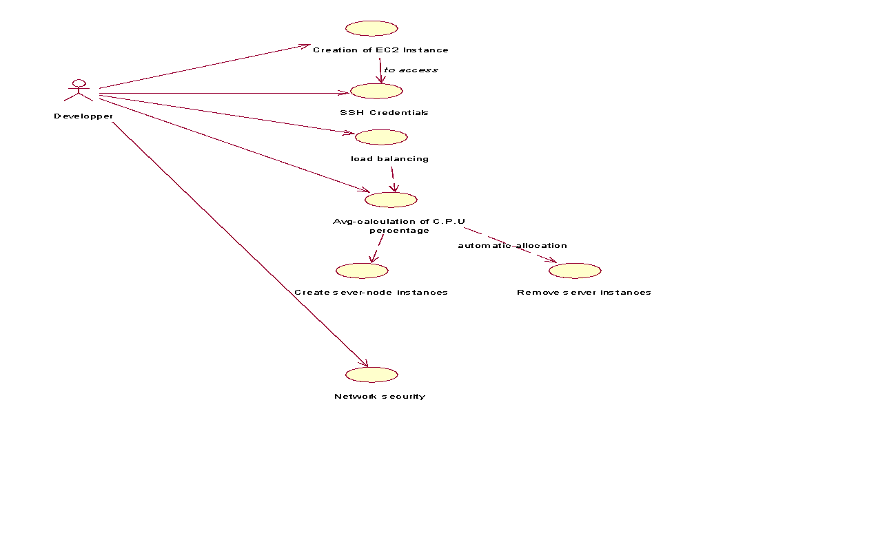

Fig 1.1: Use Case Instances

**1.8 Activity Diagram**

Activity diagram illustrates the dynamic nature of a system by modeling the flow of control from activity. An activity represents an operation on some class in the system that results in a change in the state of the system. Typically, activity diagrams are used to model workflow and internal operation.

Action state represents the no interruptible actions of objects. Action flow represents arrows illustrate the relationships among action states.

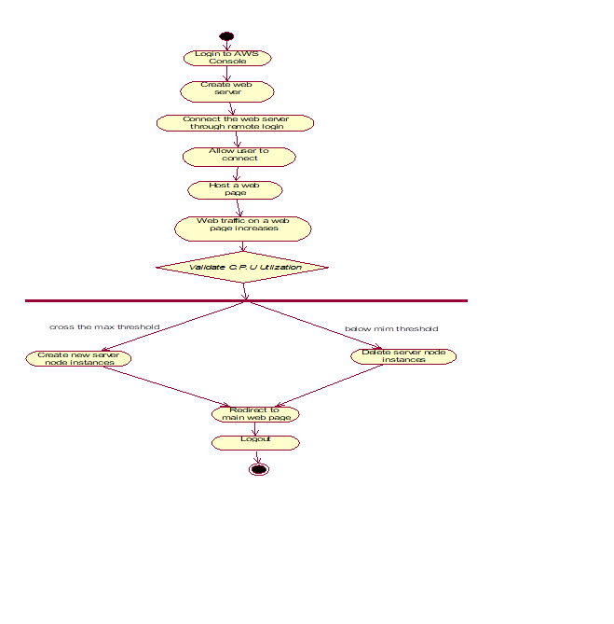

Fig 1.2: Scale In and Out Instances

**1.9 Sequence Diagram**

**S**equence diagram describes the pattern of communication among set of interacting objects. An object interacts with other objects by sending messages. The reception of a message by an object triggers the execution of an operation, which in many turns may send messages to other objects.

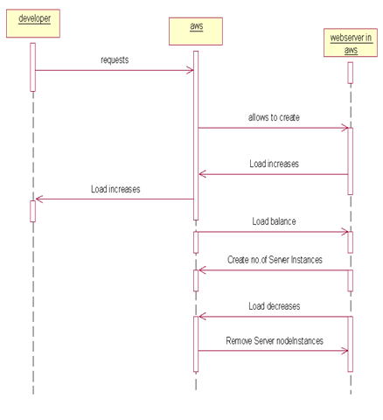

Fig 1.3: AWS working

**CHAPTER-2**

**LITERATURE SURVEY**

**2.1 Introduction**

What is Cloud Computing and what does it mean for the business. Everyone in the technology world and business are talking about it. What unique advantages does a cloud computing architecture offer to companies in today’s economic climate. Before exploring the cloud computing infrastructure and its impact on critically important areas to IT, like security, infrastructure investments, business application development and more, we shall see how traditional server concept works.

**2.1.1 Life before Cloud Computing**

**The Traditional Server Concept:**

System Administrators often used to talk about servers as a whole unit that includes the hardware, the OS, the storage, and the applications. Servers are often referred to by their function i.e. the Exchange server, the SQL server, the File server, etc. If something goes wrong If the File server fills up, or the Exchange server becomes overtaxed, then the System Administrator must add in a new server. Unless there are multiple servers, if a service experiences a hardware failure, then the service is down. System Administrators can implement clusters of servers to make them more faults tolerant. However, even clusters have limits on their scalability, and not all applications work in a clustered environment. This raised issues on server maintenance and thus originating the concept of Virtual server.

**The Virtual Server Concept**

Virtual server concept separates the server software away from the hardware. This includes the OS, the applications, and the storage for that server. Servers end up as mere files stored on a physical box, or in enterprise storage. A virtual server can be serviced by one or more hosts, and one host may house more than one virtual server. Virtual servers can still be referred to by their function i.e. email server, database server, etc. If the environment is built correctly, virtual servers will not be affected by the loss of a host. Hosts may be removed and introduced almost at will to accommodate maintenance. Virtual servers can be scaled out easily. If the administrators find that the resources supporting a virtual server are being taxed too much, they can adjust the amount of resources allocated to that virtual server. Server templates can be created in a virtual environment to be used to create multiple, identical virtual servers. Virtual servers themselves can be migrated from host to host almost at will.

**2.2 Why Cloud Computing?**

Forbe server’s operation hours are from 9AM till 5PM in a day. Then why spend resources on the server during nights when it is not actually used? If Forbe’s host their server themselves then why leaving it idle during its non-operational hours.

**Forbe’s Solution**

Host the web site in Amazon’s EC2 Elastic Compute Cloud.

Provision new servers every day, and de-provision them every night.

Pay just $0.10* per server per hour or more for higher capacity servers.

Let Amazon worry about the hardware.

# Internet of things (IoT)

The internet of things, or IoT, is a system of interrelated computing devices, mechanical and digital machines, objects, animals or people that are provided with unique identifiers ([UIDs](https://internetofthingsagenda.techtarget.com/definition/unique-identifier-UID)) and the ability to transfer data over a network without requiring human-to-human or human-to-computer interaction.

**2.3 Research papers:**

**Research paper 1**

**IoT Empowered Real Time Environment Monitoring System** --- Athena Karumbaya Department of Electronics and Communication Vellore Institute of Technology

`The Internet of Things (IoT) is a computing concept that describes a future where every day physical objects will be connected to the Internet and be able to identify themselves to other devices. In the future, every device is more likely to be connected to the web directly with the users expecting it to be responsive to their needs.[1] In this project, three modules are created which is used to monitor various environmental parameters and update it real time data to a server. The parameters measured include ambient temperature and humidity of the room, noise levels, the number of people entering and leaving the room and toxic gas detector. In case a flammable gas is detected, an alarm is triggered and an email is sent to the user’s account. Arduino is used to integrate and program the hardware components with ESP8266 being the WiFi component which connects to the host webpage. The server side is created on an IoT platform, Ubidots.

**Research paper 2**

Data centre temperature monitoring with ESP8266 based Wireless Sensor Network and cloud based dashboard with real time alert system---**[Saraswati Saha](https://ieeexplore.ieee.org/author/37086242958); [Anupam Majumdar](https://ieeexplore.ieee.org/author/37086233830)**

The Internet of Things (IoT) system proposed in this paper is an advanced solution for monitoring the temperature at different points of location in a data centre, making this temperature data visible over internet through cloud based dashboard and sending SMS and email alerts to predefined recipients when temperature rises above the safe operating zone and reaches certain high values. This helps the datacenter management team to take immediate action to rectify this temperature deviation. Also this can be monitored from anywhere anytime over online dashboard by the senior level professionals who are not present in the data center at any point in time. This Wireless Sensor Network (WSN) based monitoring system consists of temperature sensors, ESP8266 and Wi-Fi router. ESP8266 is a low power, highly integrated Wi-Fi solution from Espress if. The ESP8266 here, in this prototype, connects to `Ubidots' cloud through its API for posting temperature data to the cloud dashboard on real time and the cloud event management system generates alerts whenever the high temperature alert event is fired. Cloud events need to be configured for different alerts beforehand through the user friendly user interface of the platform. It's to be noted that the sensor used here can be leveraged to monitor the relative humidity of the data center environment as well along with the temperature of the data center. But for this prototype solution focus is kept entirely on the temperature monitoring.

**CHAPTER-3**

**AWS CLOUD**

**Amazon Web Services (AWS)**

Is owned by Amazon that provides On-demand cloud computing platforms to individuals, companies, and governments, on a paid subscription basis. The technology allows subscribers to have at their disposal a virtual cluster of computers, available at all time through the Internet.

**3.1 Why AWS?**

One of the most successful business cloud platforms is amazon web services, it mainly focus on infrastructure as a service. No other cloud vendor will not defeat Aws cloud. Because it is the first invented, what are all the strategy and concept of technology of Aws, Microsoft azure is doing copy and paste. Aws having highest revenue compare to all other clouds available in market of world. One of most wonderful features is, it supports all programming languages. Those are Dotnet, C#, Python, Shell Scripting, Go. Etc.

Developing, managing, and operating your applications requires a wide variety of technology services. Customers often ask us what represents a fully-functional, flexible technology infrastructure platform. Below, we outline requirements for a modern, robust, industry-leading technology infrastructure platform with all the benefits that the cloud brings to bear. We also provide information about how AWS delivers against these requirements and why you might need each of these capabilities.

AWS began offering its technology infrastructure platform in 2006. At this point, we have over a million active customers using AWS in every imaginable way, and have developed considerable experience operating at scale. We’ve also innovated and delivered at a very rapid pace (delivering 159 significant features and services in 2012, 280 in 2013, 516 in 2014, 722 in 2015, and 1,017 in 2016). Expect this focus on rapidly delivering what customers want to continue.

**3.2 What is Cloud Computing?**

Cloud computing is the on-demand delivery of compute power, database storage, applications, and other IT resources through a cloud services platform via the internet with pay-as-you-go pricing.

**Cloud Computing Basics**

Whether you are running applications that share photos to millions of mobile users or you’re supporting the critical operations of your business, a cloud services platform provides rapid access to flexible and low-cost IT resources. With cloud computing, you don’t need to make large upfront investments in hardware and spend a lot of time on the heavy lifting of managing that hardware. Instead, you can provision exactly the right type and size of computing resources you need to power your newest bright idea or operate your IT department. You can access as many resources as you need, almost instantly, and only pay for what you use.

**How Does Cloud Computing Work?**

Cloud computing provides a simple way to access servers, storage, databases and a broad set of application services over the Internet. A Cloud services platform such as Amazon Web Services owns and maintains the network-connected hardware required for these application services, while you provision and use what you need via a web application.

**3.3 Cloud Computing Types**

1. Infrastructure as a service

2. Platform as a service

3. Software as a service

**3.3.1 Infrastructure as a service (IAAS)**

Infrastructure as a service (IAAS) is a form of cloud computing that provides virtualized computing resources over the internet. IAAS is one of the three main categories of cloud computing services, alongside software as a service (SAAS) and platform as a service (PAAS).

**IAAS architecture and how it works**

The IAAS provider also supplies a range of services to accompany those infrastructure components. These can include detailed billing, monitoring, log access, security, load balancing and clustering, as well as storage resiliency, such as backup, replication and recovery. These services are increasingly policy-driven, enabling IAAS users to implement greater levels of automation and orchestration for important infrastructure tasks. For example, a user can implement policies to drive load balancing to maintain application availability and performance.

IAAS customers access resources and services through a wide area network (WAN), such as the internet, and can use the cloud provider's services to install the remaining elements of an application stack. For example, the user can log in to the IAAS platform to create virtual machines (VMs); install operating systems in each VM; deploy middleware, such as databases; create storage buckets for workloads and backups; and install the enterprise workload into that VM. Customers can then use the provider's services to track costs, monitor performance, balance network traffic, troubleshoot application issues, and manage disaster recovery and more. Any cloud computing model requires the participation of a provider. The provider is often a third-party organization that specializes in selling IAAS. Amazon Web Services (AWS) and Google Cloud Platform (GCP) are examples of independent IAAS providers. A business might also opt to deploy a private cloud, becoming its own provider of infrastructure services. Organizations choose IAAS because it is often easier, faster and more cost-efficient to operate a workload without having to buy, manage and support the underlying infrastructure. With IAAS, a business can simply rent or lease that infrastructure from another business.

IAAS is an effective model for workloads that are temporary, experimental or that change unexpectedly. For example, if a business is developing a new software product, it might be more cost-effective to host and test the application using an IAAS provider. Once the new software is tested and refined, the business can remove it from the IAAS environment for a more traditional, in-house deployment. Conversely, the business could commit that piece of software to a long-term IAAS deployment, where the costs of a long-term commitment may be less.

In general, IAAS customers pay on a per use basis, typically by the hour, week or month. Some IAAS providers also charge customers based on the amount of virtual machine space they use. This pay-as-you-go model eliminates the capital expense of deploying in-house hardware and software.

When a business cannot use third-party providers, a private cloud built on premises can still offer the control and scalability of IAAS -- though the cost benefits no longer apply.

**3.3.2 Platform as a service (PAAS)**

Platform as a service (PAAS) is a cloud computing model in which a third-party provider delivers hardware and software tools -- usually those needed for application development -- to users over the internet. A PAAS provider hosts the hardware and software on its own infrastructure. As a result, PAAS frees users from having to install in-house hardware and software to develop or run a new application.

**PAAS architecture and how it works**

PAAS does not typically replace a business's entire IT infrastructure. Instead, a business relies on PAAS providers for key services, such as application hosting or Java development. A PAAS provider builds and supplies a resilient and optimized environment on which users can install applications and data sets. Users can focus on creating and running applications rather than constructing and maintaining the underlying infrastructure and services. Many PAAS products are geared toward software development. These platforms offer compute and storage infrastructure, as well as text editing, version management, compiling and testing services that help developers create new software more quickly and efficiently. A PAAS product can also enable development teams to collaborate and work together, regardless of their physical location.

**3.3.3 Software as a service (SAAS)**

Software as a service (SAAS) is a software distribution model in which a third-party provider hosts application and makes them available to customers over the Internet. SAAS is one of three main categories of cloud computing, alongside infrastructure as a service (IAAS) and platform as a service (PAAS).

SAAS is closely related to the application service provider (ASP) and on demand computing software delivery models. The hosted application management model of SAAS is similar to ASP, where the provider hosts the customer’s software and delivers it to approved end users over the internet. In the software on demand SAAS model, the provider gives customers network-based access to a single copy of an application that the provider created specifically for SAAS distribution. The application’s source code is the same for all customers and when new features or functionalities are rolled out, they are rolled out to all customers. Depending upon the service level agreement (SLA), the customer’s data for each model may be stored locally, in the cloud or both locally and in the cloud. Organizations can integrate SAAS applications with other software using application programming interfaces (APIs). For example, a business can write its own software tools and use the SAAS provider's APIs to integrate those tools with the SAAS offering.

There are SAAS applications for fundamental business technologies, such as email, sales management, customer relationship management (CRM), financial management, human resource management (HRM), billing and collaboration. Leading SAAS providers include Salesforce, Oracle, SAP, Intuit and Microsoft SAAS applications are used by a range of IT professionals and business users, as well as C-level executives.

**3.4 Advantages and Benefits of Cloud Computing**

**1. Trade capital expense for variable expense**

Instead of having to invest heavily in data centers and servers before you know how you’re going to use them, you can only pay when you consume computing resources, and only pay for how much you consume.

**2. Benefit from massive economies of scale**

By using cloud computing, you can achieve a lower variable cost than you can get on your own. Because usage from hundreds of thousands of customers are aggregated in the cloud, providers such as Amazon Web Services can achieve higher economies of scale which translates into lower pay as you go prices.

**Stop guessing capacity**

Eliminate guessing on your infrastructure capacity needs. When you make a capacity decision prior to deploying an application, you often either end up sitting on expensive idle resources or dealing with limited capacity. With cloud computing, these problems go away. You can access as much or as little as you need, and scale up and down as required with only a few minutes’ notice.

**3. Increase speed and agility**

In a cloud computing environment, new IT resources are only ever a click away, which means you reduce the time it takes to make those resources available to your developers from weeks to just minutes. This results in a dramatic increase in agility for the organization, since the cost and time it takes to experiment and develop is significantly lower.

**Stop spending money on running and maintaining data centers**

Focus on projects that differentiate your business, not the infrastructure. Cloud computing lets you focus on your own customers, rather than on the heavy lifting of racking, stacking and powering servers.

**CHAPTER-4**

**INTERNET OF THINGS**

IOT means Internet of Things, the main aim of our project AWS Cloud and Network Security is to retrieve the data of cloud from anywhere at any time, if we have Internet Connection. In this project we are using sensors for getting information about temperature, humidity, rainfall at a particular location.

# In this process, we have used different types of sensors they are For temperature and humidity information we are using DHT11 sensor. This is connected with Nodemcu.

# 4.1 DHT11 - Humidity and Temperature Sensor

The DHT11 is a basic, low-cost digital temperature and humidity sensor. It uses a capacitive humidity sensor and a thermistor to measure the surrounding air, and spits out a digital signal on the data pin (no analog input pins needed).

It is fairly simple to use, but requires careful timing to grab data. The only real downside of this sensor is you can only get new data from it once every 2 seconds.

# Details

This sensor includes a resistive-type humidity measurement component and an NTC temperature measurement component, and connects to a high-performance 8-bit microcontroller, offering excellent quality, fast response, anti-interference ability and cost-effectiveness. Each DHT11 element is strictly calibrated in the laboratory that is extremely accurate on humidity calibration. The calibration coefficients are stored as programs in the OTP memory, which are used by the sensors internal signal detecting process.

The single-wire serial interface makes system integration quick and easy. Its small size, low power consumption and up-to-20 meter signal transmission making it the best choice for various applications, including those most demanding ones. The component is 4-pin single row pin package.

* 1. **Specifications**

# TABLE 4.1: Ranges of DHT11 Sensor

# 

DHT11’s power supply is 3-5.5V DC. When power is supplied to the sensor, do not send any instruction to the sensor in within one second in order to pass the unstable status. One capacitor valued 100nF can be added between VDD and GND for power filtering.

## **SDK (Software Development Kit)**

Download source code + project articles by clicking following link

http://www.sunrom.com/files/3732.zip

It contains details for AVR, PIC and Arduino projects.

# Communication Process: Serial Interface (Single-Wire Two-Way)

The interesting thing in this module is the protocol that uses to transfer data. All the sensor readings are sent using a single wire bus which reduces the cost and extends the distance. In order to send data over a bus you have to describe the way the data will be transferred, so that transmitter and receiver can understand what says each other. This is what a protocol does. It describes the way the data are transmitted. On DHT-11 the 1-wire data bus is pulled up with a resistor to VCC. So, if nothing is occurred the voltage on the bus is equal to VCC.

Communication Format can be separated into three stages

* 1. Request
  2. Response
  3. Data Reading

1. **Request**

To make the DHT-11 to send you the sensor readings you have to send it a request. The request is, to pull down the bus for more than 18ms in order to give DHT time to understand it and then pull it up for 40uS.

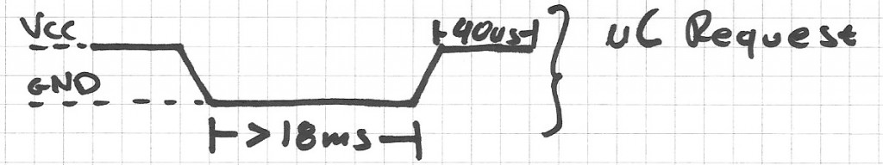

1. **Response**

What comes after the request is the DHT-11 response. This is an automatic reply from DHT which indicates that DHT received your request. The response is ~54uS low and 80uS high.

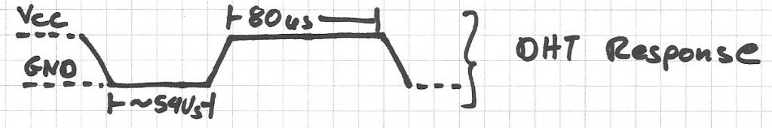

1. **Data Reading**

What will come after the response is the sensor data. The data will be packed in a packet of 5 segments of 8-bits each. Totally 5×8 =40bits.

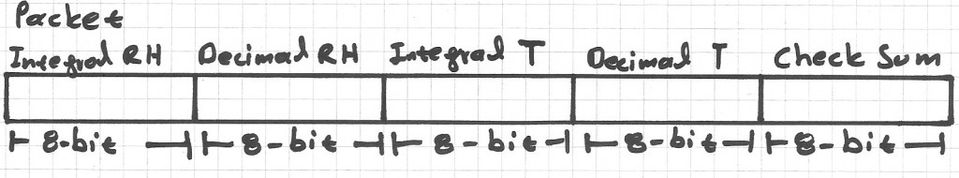

First two segments are Humidity read, integral & decimal. Following two are Temperature read in Celsius, integral & decimal and the last segment is the Check Sum which is the sum of the 4 first segments. If Check Sum's value isn't the same as the sum of the first 4 segments that means that data received isn't correct.

**How to Identify Bits**

Each bit sent is a follow of ~54uS Low in the bus and ~24uS to 70uS High depending on the value of the bit.

Bit '0' : ~54uS Low and ~24uS High

Bit '1' : ~54uS Low and ~70uS High

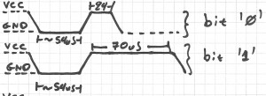

**End Of Frame**

At the end of packet DHT sends a ~54uS Low level, pulls the bus to High and goes to sleep mode.

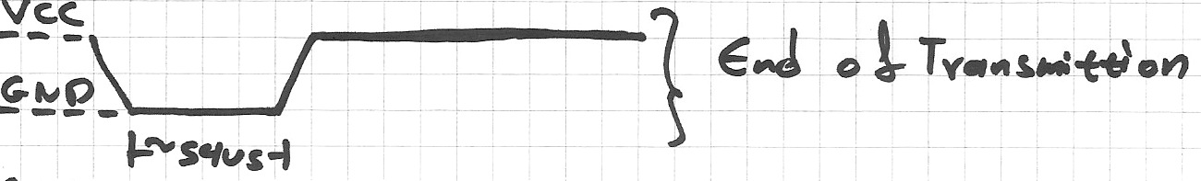

**Logic Analyzer Snapshots**

If we zoom at the data bits we can read the values. You can see after the Request follows the Response, and Data bits. I have drawn some color notes to be more understandable.

If we decode the above data we have.Humidity 0b00101011.0b00000000 = 43.0% (43 is integral part and .0 is decimal part) Temperature 0b00010111 = 23 C.

The last two segments can't be seen in this image because of zoom.

## **Implementation**

What we have to do to read a DHT-11 sensor is:

1. Send request
2. Read response
3. Read each data segment and save it to a buffer
4. Sum the segments and check if the result is the same as CheckSum

If the CheckSum is correct, the values are correct so we can use them. If CheckSum is wrong we discard the packet. To read the data bits can use a counter and start count micro Seconds of High level. For counts > 24uS we replace with bit '1'. For counts <=24 we replace with bit'0'

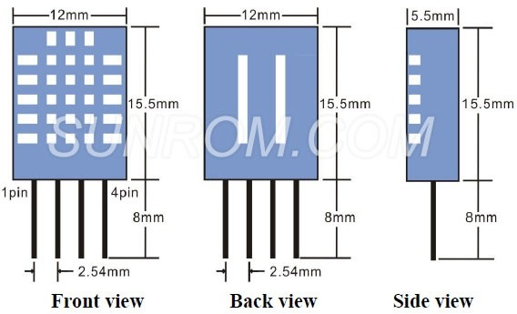

Fig 4.1: 3-D View of DHT11 Senor

**4.3 DHT11 Temperature and Humidity sensor**

DHT11 sensor is used for measuring both humidity and temperature values. It can measure relative humidity in percentage (20 to 90% RH) and temperature in degree Celsius in the range of 0 to 50°C.It has 3 pins. They are:

1. VCC

2. DATA OUT

3. GND



Fig 4.2: DHT11 Sensor

**4.4 Node MCU**

NodeMCU Dev. Kit/board consist of ESP8266 Wi-Fi enabled chip. The ESP8266 is a low-cost Wi-Fi chip developed by Espress if Systems with TCP/IP protocol. Node MCU Dev. Kit has Arduino like Analog (i.e. A0) and Digital (D0-D8) pins on its board. It supports serial communication protocols i.e. UART, SPI, I2C etc. Using such serial protocols we can connect it with serial devices like I2C enabled LCD display, Magnetometer HMC5883, MPU-6050 Gyro meter + Accelerometer, RTC chips, GPS modules, touch screen displays, SD cards etc.

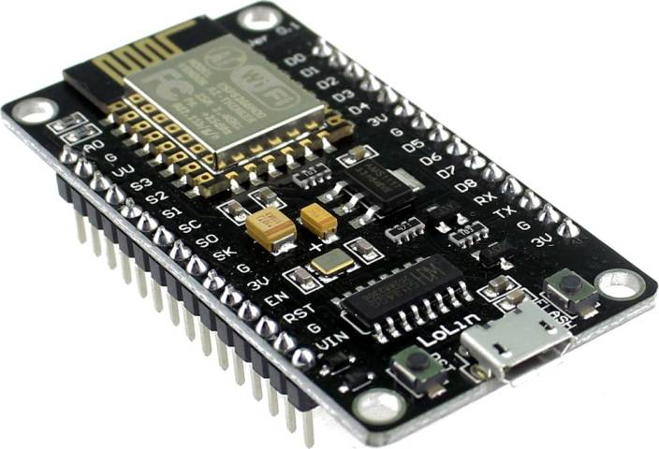

Fig 4.3: Node MCU

NodeMCU is an open source [IoT](https://en.wikipedia.org/wiki/Internet_of_Things" \o "Internet of Things) platform. It includes [firmware](https://en.wikipedia.org/wiki/Firmware) which runs on the [ESP8266](https://en.wikipedia.org/wiki/ESP8266) [Wi-Fi](https://en.wikipedia.org/wiki/Wi-Fi) [SoC](https://en.wikipedia.org/wiki/System_on_a_chip" \o "System on a chip) from [Espress if Systems](https://en.wikipedia.org/w/index.php?title=Espressif_Systems&action=edit&redlink=1" \o "Espressif Systems (page does not exist)), and hardware which is based on the ESP-12 module. The term "NodeMCU" by default refers to the firmware rather than the development kits. The firmware uses the [Lua](https://en.wikipedia.org/wiki/Lua_(programming_language)" \o "Lua (programming language)) scripting language. It is based on the eLua project, and built on the Espress if Non-OS SDK for ESP8266. It uses many open source projects, such as lua-cjson and [SPIFFS](https://en.wikipedia.org/w/index.php?title=SPIFFS&action=edit&redlink=1).

* ESP8266 CP2102 NodeMCU LUA ESP-12E WIFI Serial Wireless Module.
* Built-in Micro-USB, with flash and reset switches, easy to program.
* Full I/O port and Wireless 802.11 supported, direct download no need to reset.
* Arduino compatible, works great with the latest Arduino IDE/Mongoose IoT/Micropython.

**4.4.1 DHT11 SENSOR CONNECTION WITH NODEMCU**

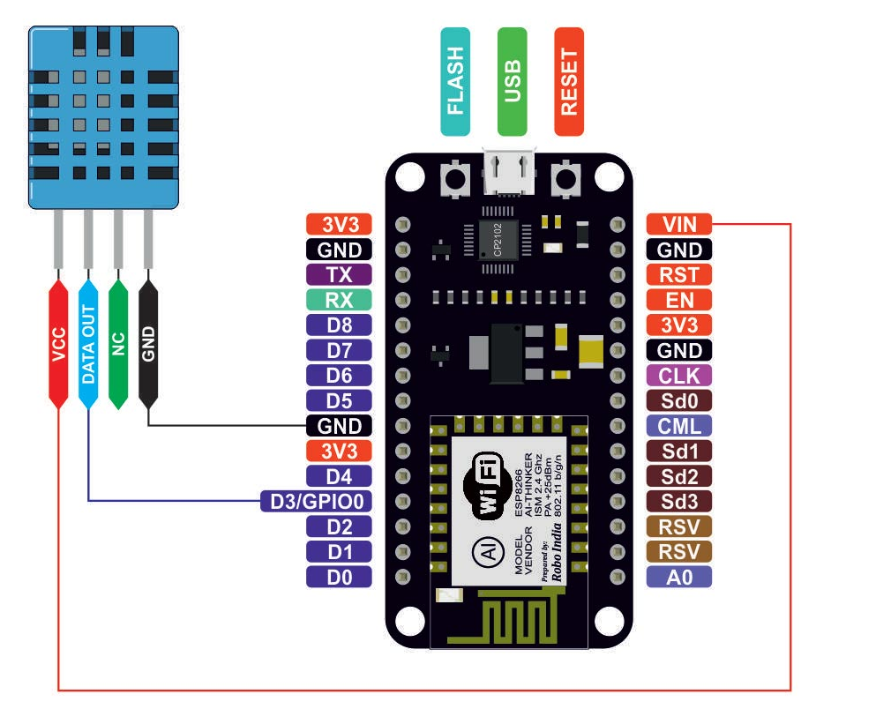

Fig 4.4: Pin Diagram of Node MCU

**Connection of NodeMcu With Dht11 Sensor**

**Pin 1** of the DHT11 goes into **+3v** of the Node MCU.

**Pin 2** of the DHT11 goes into Digital Pin **D3** of the Node MCU.

**Pin 3** of the DHT11 goes into Ground Pin (**GND**) of the Node MCU.

**4.5** **Rain Drop Sensor**

The rain sensor module is an easy tool for rain detection. It can be used as a switch when raindrop falls through the raining board and also for measuring rainfall intensity. The module features, a rain board and the control board that is separate for more convenience, power indicator LED and an adjustable sensitivity though a potentiometer

The analog output is used in detection of drops in the amount of rainfall. Connected to 5V power supply, the LED will turn on when induction board has no rain drop, and DO output is high. When dropping a little amount water, DO output is low, the switch indicator will turn on. Brush off the water droplets, and when restored to the initial state, outputs high level.

**Specifications**

• Adopts high quality of RF-04 double sided material.

• Area: 5cm x 4cm nickel plate on side.

• Anti-oxidation, anti-conductivity, with long use time.

• Comparator output signal clean waveform is good, driving ability, over 15mA.

• Potentiometer adjust the sensitivity.

• Working voltage 5V.

• Output format: Digital switching output (0 and 1) and analog voltage output AO.

• With bolt holes for easy installation.

• Small board PCB size: 3.2cm x 1.4cm.

• Uses a wide voltage LM393 comparator.

**Pin Configuration**

1. VCC: 5V DC

2. GND: ground

3. DO: high/low output

4. AO: analog output 1 2 3 4

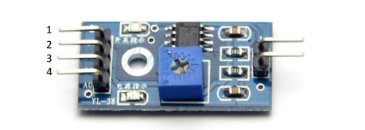

Fig 4.5: Rain Drop Sensor

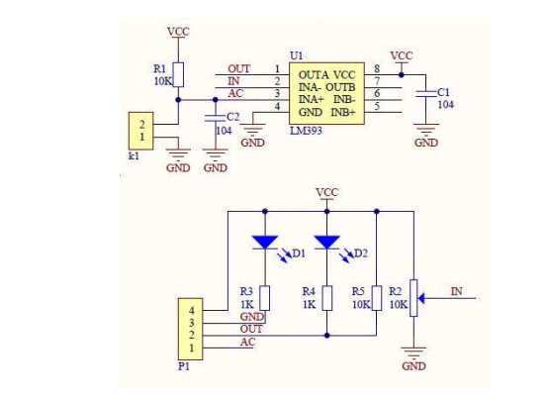

Fig 4.6: Schematic Diagram

**Connecting sensor on bread board**

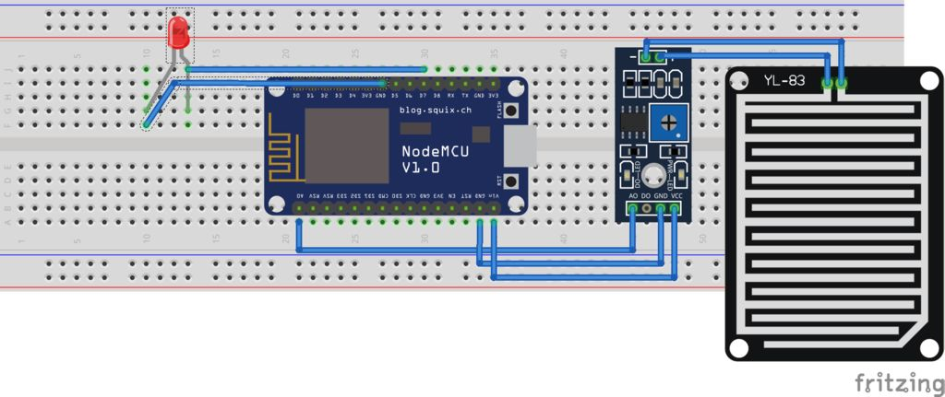

Fig 4.7: Connecting of Rain Sensor with Node MCU

**Working Principle of Raindrop Sensor**

[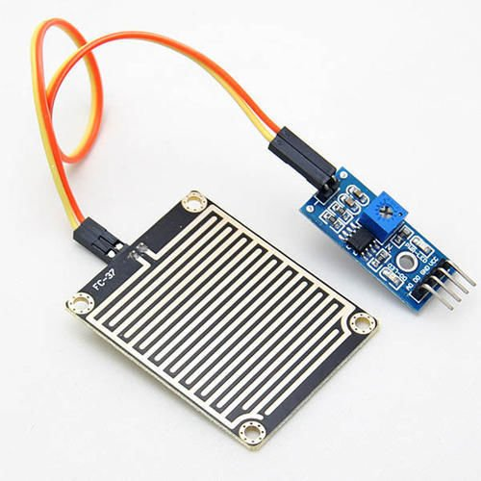](https://cdn.instructables.com/FZF/E2NC/JK2UIKLW/FZFE2NCJK2UIKLW.LARGE.jpg)

Fig 4.8: Rain Drop Sensor

Raindrop sensor is basically a board on which nickel is coated in the form of lines. It works on the principal of resistance. When there is no rain drop on board. Resistance is high so we get high voltage according to V=IR. When rain drop present it reduces the resistance because water is conductor of electricity and presence of water connects nickel lines in parallel so reduced resistance and reduced voltage drop across it.

# Yl-83 Rain Detector

# 

Fig 4.9: Vaisala YL-83 Rain Detector

Rain and snow are quickly and accurately detected with the YL-83 Rain Detector. The YL-83 operates via droplet detection rather than by signal level threshold.

A special delay circuitry allows about two-minute interval between raindrops before assuming an OFF (no rain) position. This enables the sensor to accurately distinguish between rain cessation and light rain.

The YL-83 also features an analog Rain Signal for estimating rain intensity. Since this signal is proportional to the percentage of moist or wet area on the sensor plate, rain intensity has a direct impact on the amplitude and variation of this analog signal.

**Features/Benefits**

* Fast and accurate precipitation detection (ON/OFF)
* Rain intensity measurement
* Maintenance
* Heating element for keeping sensor free of snow and condensed moisture, and for quick drying

**4.6 Installation of libraries**

You need to install the **DHTLib** library. It has all the functions needed to get the humidity and temperature readings from the sensor. It’s easy to install.

Open up the **Arduino IDE,** then go to **Sketch** > **Include Library** > **Manage Libraries** > **Search DHTLib**

After it’s installed, upload this program to the Node MCU and check output in the serial monitor.

1. After connecting the devices, the code is written and sends to the cloud through MQTT protocol.
2. There the code is uploaded into Arduino and it shows live data of temperature and humidity of a particular location for every 5 minutes.

**4.7 MQTT Protocol**

MQTT means Message Queuing Telemetry Transport. It is small size, light weight, low power usage, minimized data packets and ease of implementation .it is used for “machine-to-machine” connection.

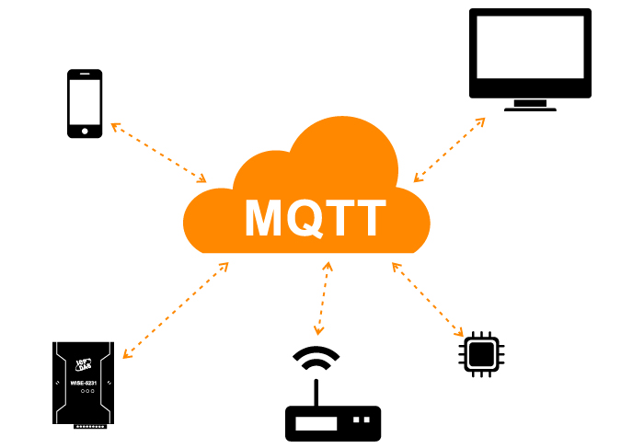

Fig 4.10: MQTT Protocol

**Features**

MQTT has unique features you can hardly find in other protocols, like:

* It’s a lightweight protocol. So, it’s easy to implement in software and fast in data transmission.
* It’s based on a messaging technique.
* Minimized data packets. Hence, low network usage.
* Low power usage. As a result, it saves the connected device’s battery.

**Working**

MQTT is based on clients and a server. The server is the one who is responsible for handling the client’s requests of receiving or sending data between each other. MQTT server is called a broker and the clients are simply the connected devices.

* When a device (a client) wants to send data to the broker, we call this operation a “publish”.
* When a device (a client) wants to receive data from the broker, we call this operation a “subscribe”.
* Publish, is the process a device does to send its message to the broker.
* Subscribe, where a device does to retrieve a message from the broker.

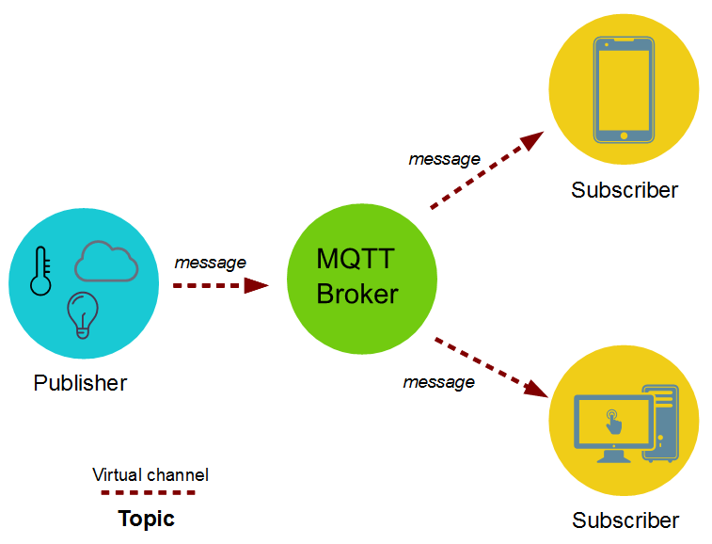

Fig 4.11: MQTT Broker

**4.7.1 Sending sensor data to client through MQTT protocol**

The data such as temperature and humidity values from publisher is send to the **MQTT broker**. The broker role here is to take the message “temperature value” and deliver through a message to the subscriber phone or application.

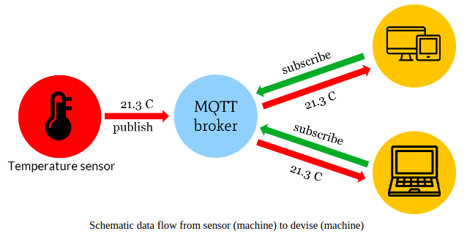

Fig 4.12: MQTT Schematic Data Flow

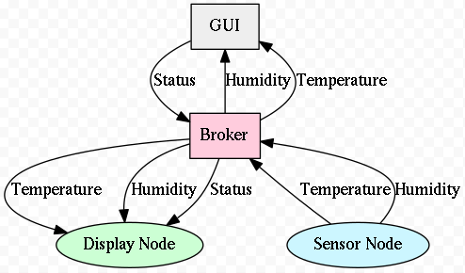

Fig 4.13: MQTT Display INFO

**4.7.2 Configure MQTT**

First of all, you need to have an AWS account. If you don’t have one, you can create a new account on AWS ([https://aws.amazon.com](https://aws.amazon.com/)) and get one-year computing, storage and several other services for free using the so called “Free Tier”.

1. Logon to the AWS Console and then select EC2 in services Section

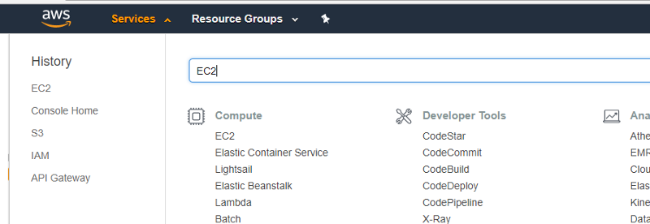

Select EC2

2. Select the preferred AWS region and then launch a new instance

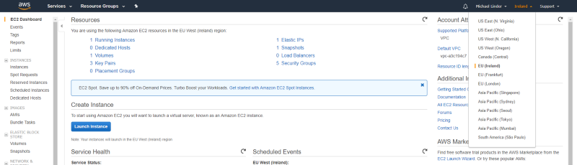

Select AWS region and launch

3. Select Ubuntu Server



4. Select an instance type

In order to use the free tier contingent, it’s recommended to use t2.micro for testing purposes.

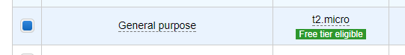

t2.micro selection

5. Configure security group

In this example following ports will be used:

**Step 1: Install Mosquitto**

Log into the AWS Ubuntu 16/18 machine.

$ sudo apt-get update

Install

$ sudo apt-get install mosquitto mosquitto-clients

The command above installs both the mosquitto broker and the publish / subscribe clients. The mosquitto broker is now installed and active. You can listen to declare any channel to subscribe and publish to test it.

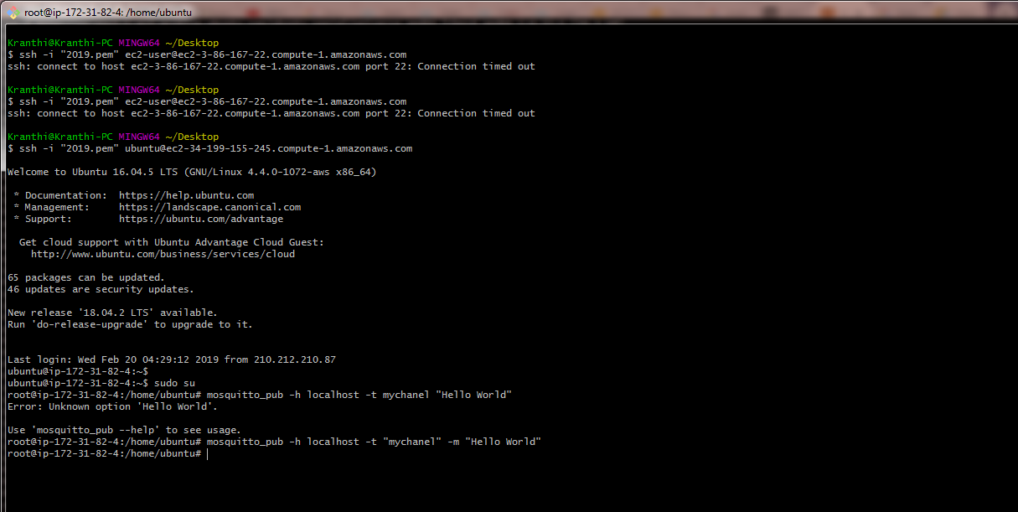

open the duplicate session for this Ubuntu, type the same command for publish

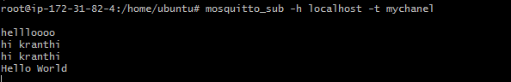**CHAPTER-5**

**AWS SERVICES**

**5.1 Introduction**

Amazon Elastic Compute Cloud (Amazon EC2) provides scalable computing capacity in the Amazon Web Services (AWS) cloud. Using Amazon EC2 eliminates your need to invest in hardware up front, so you can develop and deploy applications faster. You can use Amazon EC2 to launch as many or as few virtual servers as you need, configure security and networking, and manage storage. Amazon EC2 enables you to scale up or down to handle changes in requirements or spikes in popularity, reducing your need to forecast traffic.

**5.1.1 Features of Amazon EC2**

Amazon EC2 provides the following features:

1. Virtual computing environments, known as instances.

2. Preconfigured templates for your instances, known as Amazon Machine Images (AMIs), that package the bits you need for your server (including the operating system and additional software).

3. Various configurations of CPU, memory, storage, and networking capacity for your instances, known as instance types.

4. Secure login information for your instances using key pairs, Storage volumes for temporary data that's deleted when you stop or terminate your instance, known as instance store volumes.

5. Persistent storage volumes for your data using Amazon Elastic Block Store (Amazon EBS), known as Amazon EBS volumes.

6. Multiple physical locations for your resources, such as instances and Amazon EBS volumes, known as regions and Availability Zones.

7. A firewall that enables you to specify the protocols, ports, and source IP ranges that can reach your instances using security groups.

8. Metadata, known as tags, that you can create and assign to your Amazon EC2 resources.

9. Virtual networks you can create that are logically isolated from the rest of the AWS cloud, and that you can optionally connect to your own network, known as virtual private clouds (VPCs).

**5.1.2 How to launch an EC2 instance on AWS**

Now we need to deploy this web portal on our EC2 instance to make this portal available for multiple users who wants to make use of.

**Creation of Instance in AWS Console**

**Step 1:** Choose the Instance option in AWS EC2.

**Step 2:** Launch Instance that was on the top right side of the screen displayed.

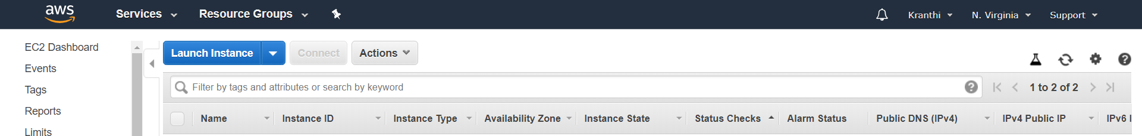

**Step 3:** Choose an Amazon Machine Image(AMI).We choose (**Amazon Linux AMI 2018.03.0 (HVM), SSD Volume Type** - ami-0080e4c5bc078760e) free tier to launch our web portal.

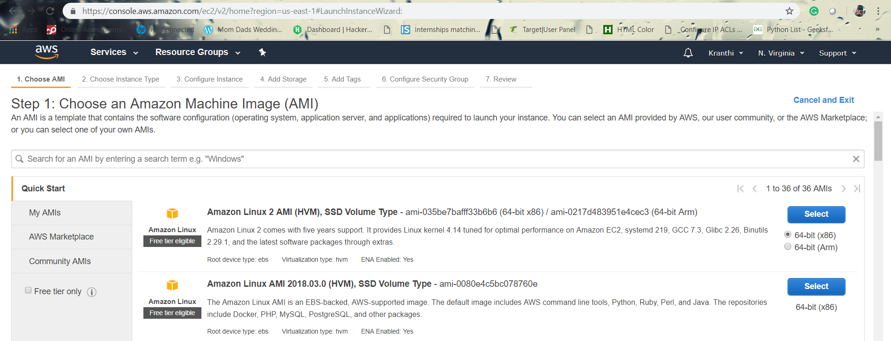

**Step 4:** Now choose an Instance type which fits to different use cases. Instances are Virtual Web servers that run our application. We choose (**:** t2.micro (Variable ECUs, 1 vCPUs, 2.5 GHz, Intel Xeon Family, 1 GiB memory, EBS only)) for general purpose.

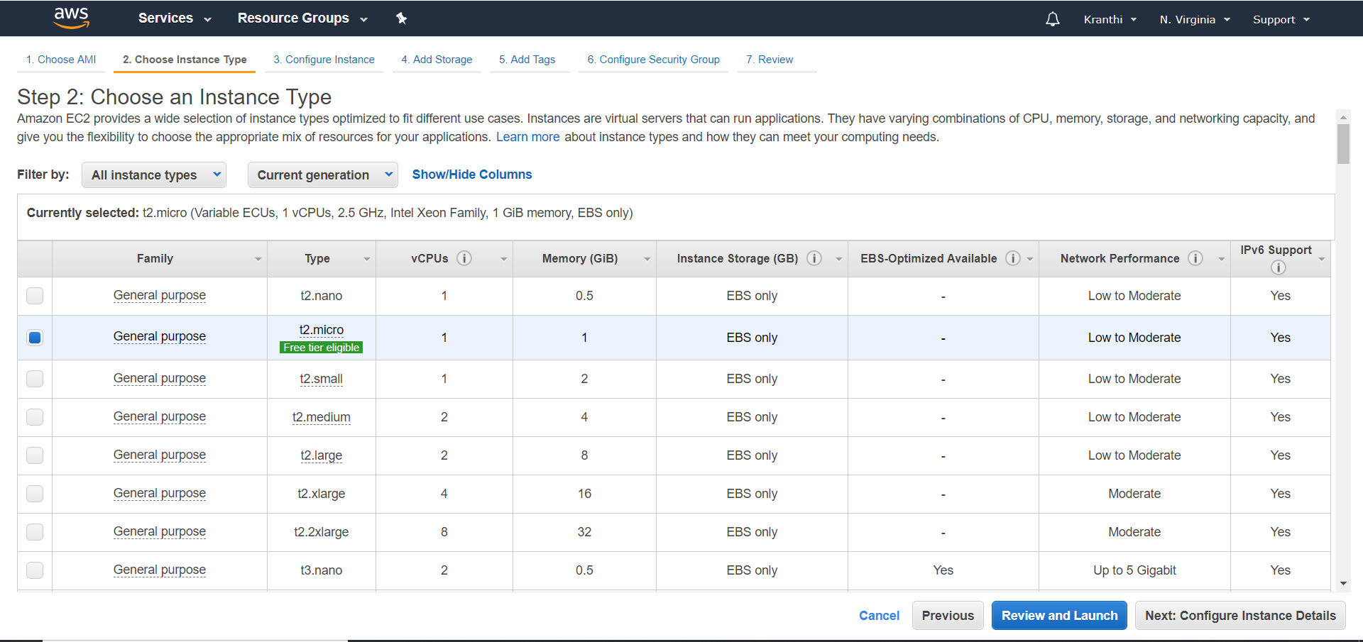

**Step 5:** Configure Instance details

Configure the instance to suit your requirements. You can launch multiple instances from the same AMI, request Spot instances to take advantage of the lower pricing, assign an access management role to the instance, and more.

**Step 6:** Add security groups

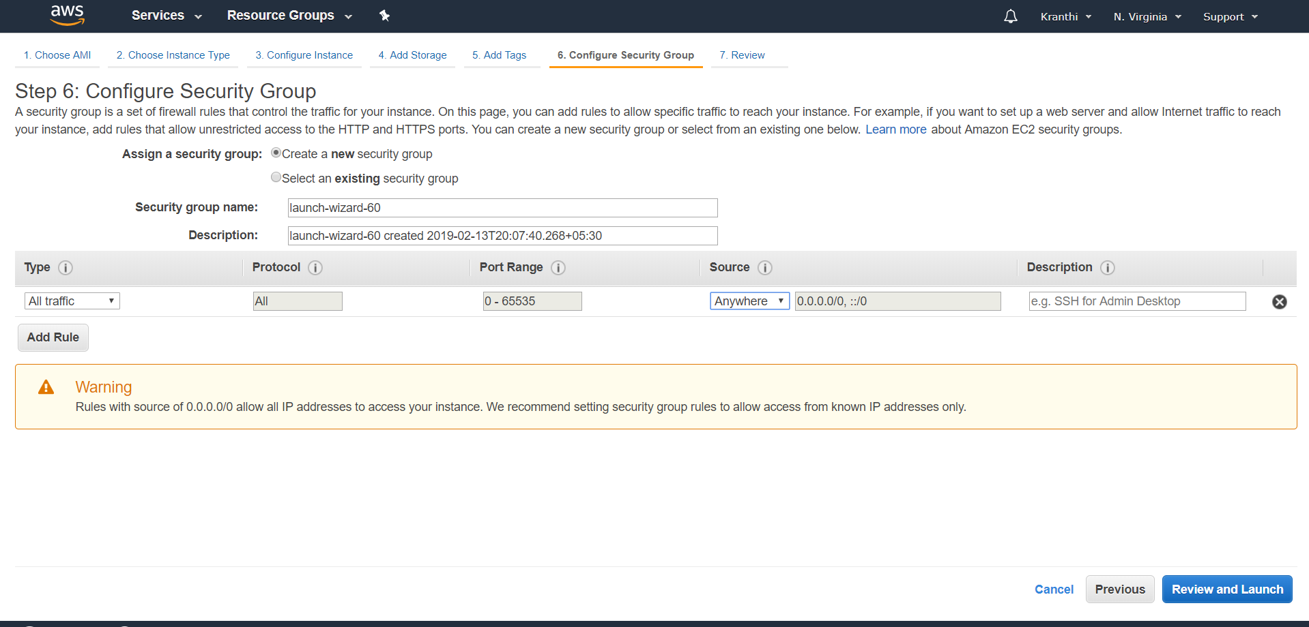

**Step 7:** On the **Review Instance Launch** page, choose **Launch**.

When prompted for a key pair, select **Choose an existing key pair**, then select the key pair that you created when getting set up.

Alternatively, you can create a new key pair. Select **Create a new key pair**, enter a name for the key pair, and then choose **Download Key Pair**.

This is the only chance to save the private key file, so be sure to download it. Save the private key file in a safe place. You'll need to provide the name of your key pair when launching an instance and the corresponding private key each time you connect to the instance.

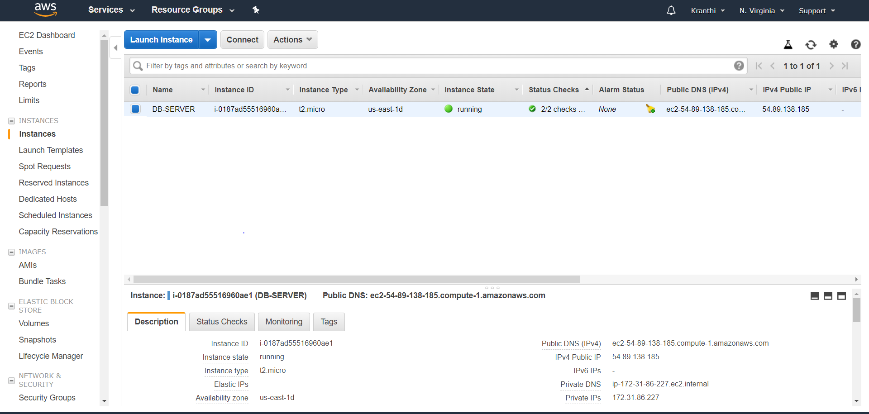

1. Now launch the web portal on the created EC2 Instance. To deploy the web portal, we need to have a little idea about LINUX.

2. Install and run Gitbash, to manage ec2 instances.

3. Install filezilla. To move our web code files from desktop to cloud EC2 instance.

**5.1.3 Execute the following commands on Gitbash console:**

1. To connect EC2 instance remotely use the below command.

$ssh -i "2019.pem" [ec2-user@ec2-3-83-103-44.compute-1.amazonaws.com](mailto:ec2-user@ec2-3-83-103-44.compute-1.amazonaws.com)

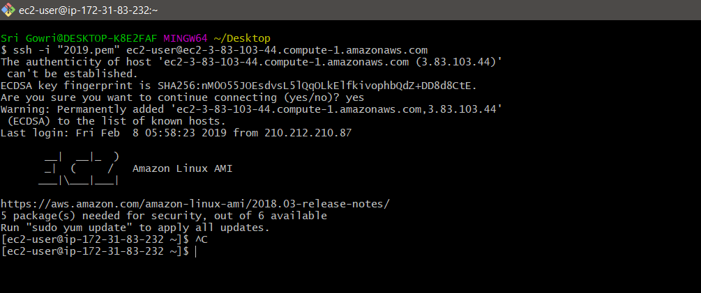

Fig 5.1: Git Bash Console

**5.1.4 Procedure for running scripts on server:**

* Sudo su //user permissions to access the EC2
* Ls
* Cd Resources/
* ls
* chmod 700 db_setup.sh
* chmod 700 initialSetupwensiteDeploy.sh
* yum install mysql-server
* service mysqld start
* ./db_setup.sh
* mysql -u root
* mysql> show databases;
* [root@ip-172-31-84-75 Resources]# **ls**
* db_setup.sh initialSetupWensiteDeploy.sh User.sql
* [root@ip-172-31-84-75 Resources]# **mysql atmospheredb <User.sql**
* [root@ip-172-31-84-75 Resources]# **mv initialSetupWensiteDeploy.sh /home/ec2-user/**
* [root@ip-172-31-84-75 Resources]# **ls**
* db_setup.sh User.sql
* [root@ip-172-31-84-75 Resources]# **cd ..**
* [root@ip-172-31-84-75 ec2-user]# **ls**
* as.pem initialSetupWensiteDeploy.sh Resources
* [root@ip-172-31-84-75 ec2-user]# **./initialSetupWensieDeploy.sh**

**5.1.5 Installing the Node Source Node.js 10**

* [root@ip-172-31-84-75 ec2-user]# **cd db**
* [root@ip-172-31-84-75 db]# **ls**
* index.js public
* [root@ip-172-31-84-75 db]# **mv index.js /home/ec2-user/website-deploy/**
* [root@ip-172-31-84-75 db]# **mv public /home/ec2-user/website-deploy/**
* [root@ip-172-31-84-75 db]# **ls**
* [root@ip-172-31-84-75 db]# **cd ..**
* [root@ip-172-31-84-75 db]# **npm install express –save**
* [root@ip-172-31-84-75 db]# **npm install mysql --save**
* [root@ip-172-31-84-75 ec2-user]# **cd wbsite-deploy/**
* [root@ip-172-31-84-75 wbsite-deploy]# **ls**

index.js node_modules package.json package-lock.json public

* [root@ip-172-31-84-75 wbsite-deploy]# **node index.js**

**5.2 ELASTIC LOAD BALANCER**

**5.2.1 Introduction**

Elastic Load Balancing automatically distributes incoming application traffic across multiple targets, such as Amazon EC2 instances, containers, IP addresses, and Lambda functions. It can handle the varying load of your application traffic in a single Availability Zone or across multiple Availability Zones. Elastic Load Balancing offers three types of load balancers that all feature the high availability, automatic scaling, and robust security necessary to make your applications fault tolerant.

These are classified into 3 types, they are Application Load Balancer, Network Load Balancer, and Classic Load Balancer. In our project we have used Application Load Balancer, this operates at the request level (layer 7), routing traffic to targets – EC2 instances, containers, etc. This provides advanced request routing targeted at delivery of modern application architectures. This simplifies and improves the security of our application, by ensuring that the latest SSl/TLS ciphers and protocols are used at all times.

**5.2.2 ADVANTAGES**

**High Availability**

Elastic Load Balancing automatically distributes traffic across multiple targets – Amazon EC2 instances, containers and IP addresses – in a single Availability Zone or multiple Availability Zones.

**Health Checks**

An Application Load Balancer routes traffic only to healthy targets. With an Application Load Balancer, you get improved insight into the health of your applications in two ways: (1) health check improvements that allow you to configure detailed error codes from 200-499. The health checks allow you to monitor the health of each of your services behind the load balancer; and (2) new metrics that give insight into traffic for each of the services running on an EC2 instance.

**5.2.3 How to add Load Balancer in AWS**

**Step 1:** Login to the AWS Console.

**Step 2:** Select EC2 Instances, there you find Load Balancer.

**Step 3:** Choose Create Load Balancer that appeared on the screen below.

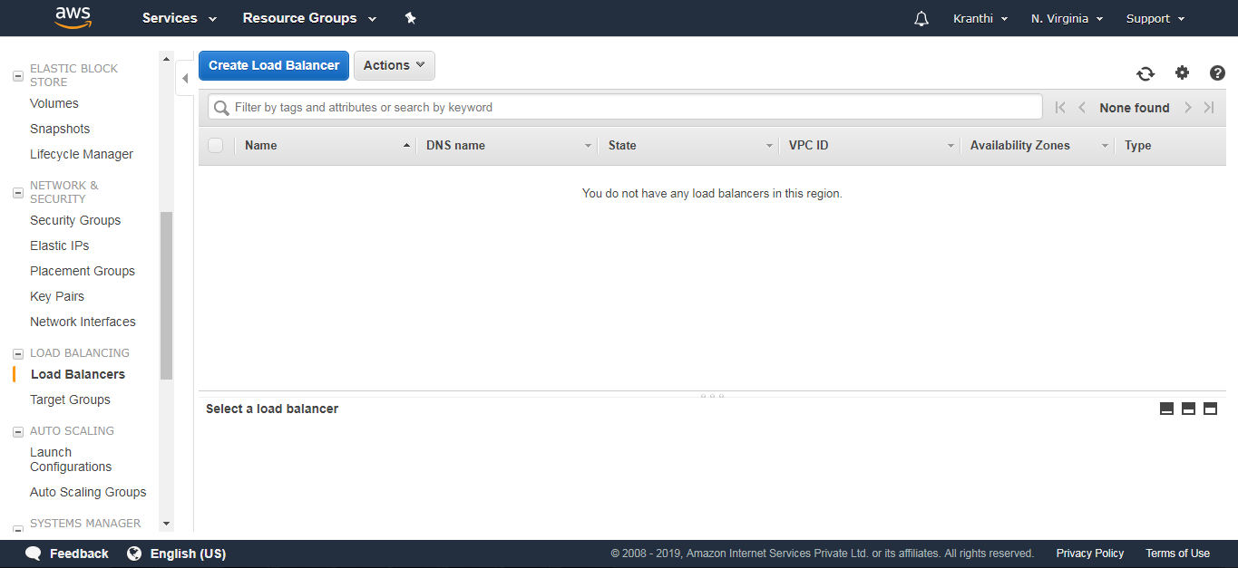

**Step 4:** Select Application Load Balancer and click on create.

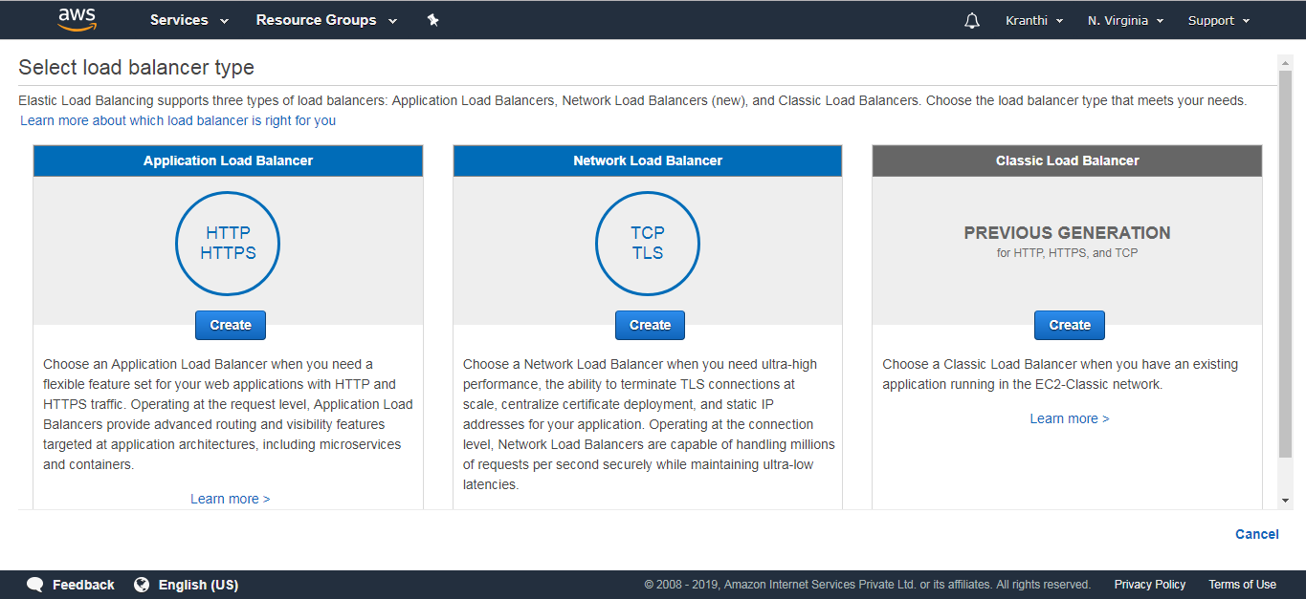

Fig 5.2: Load Balancers

**Step 5:** Configure Load Balancer.

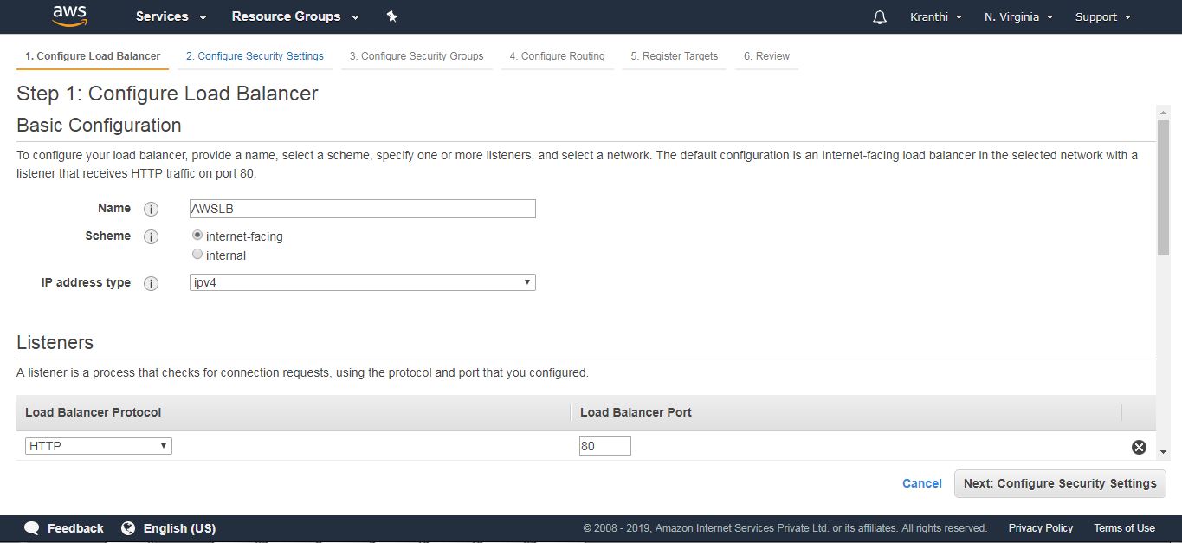

Add the availability Zones

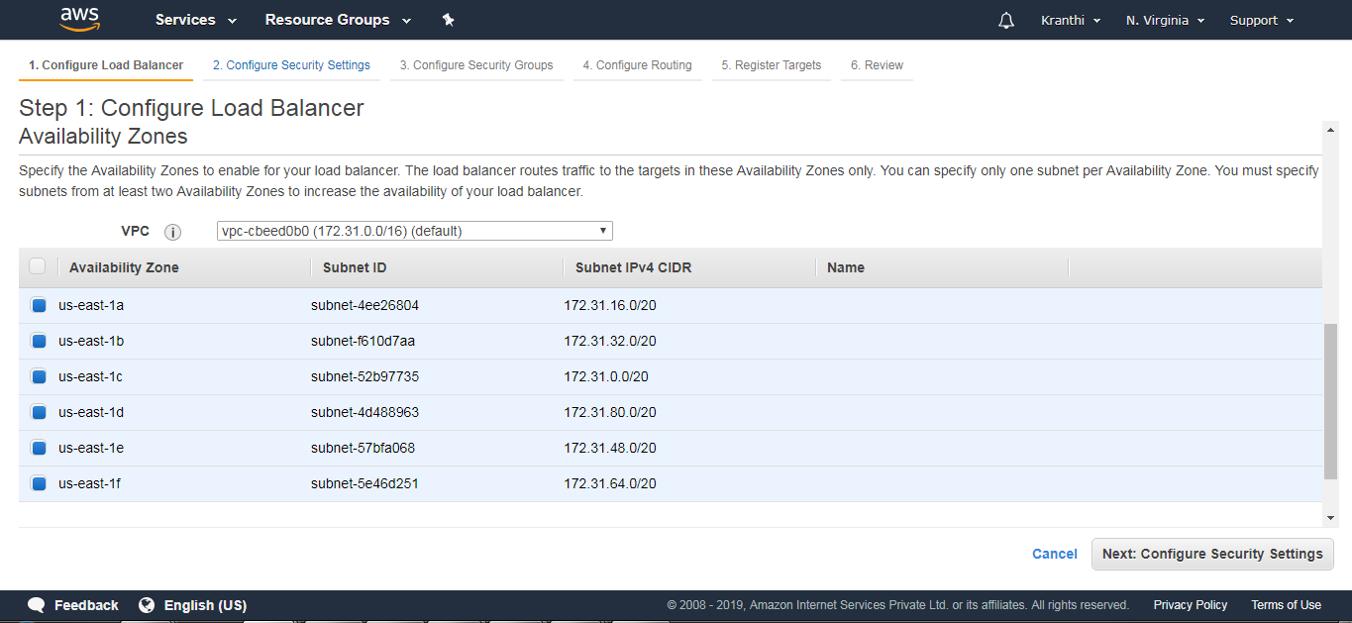

Step 6: Configure Security groups.

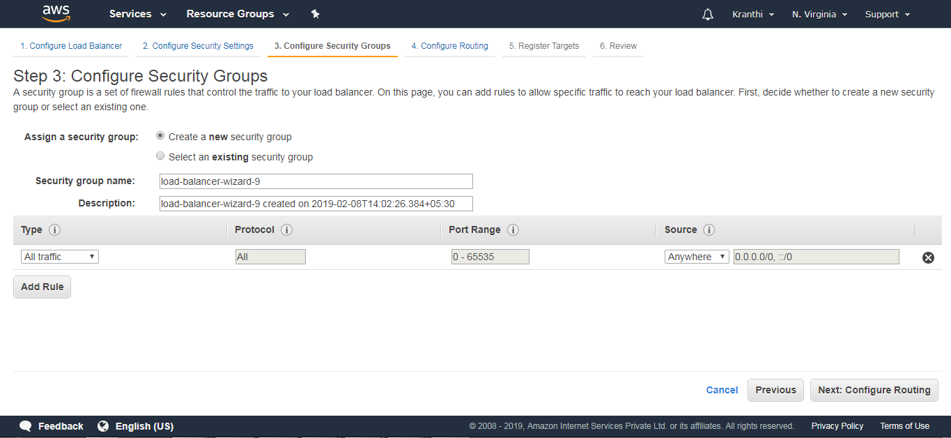

**Step 7:** Configure Routing

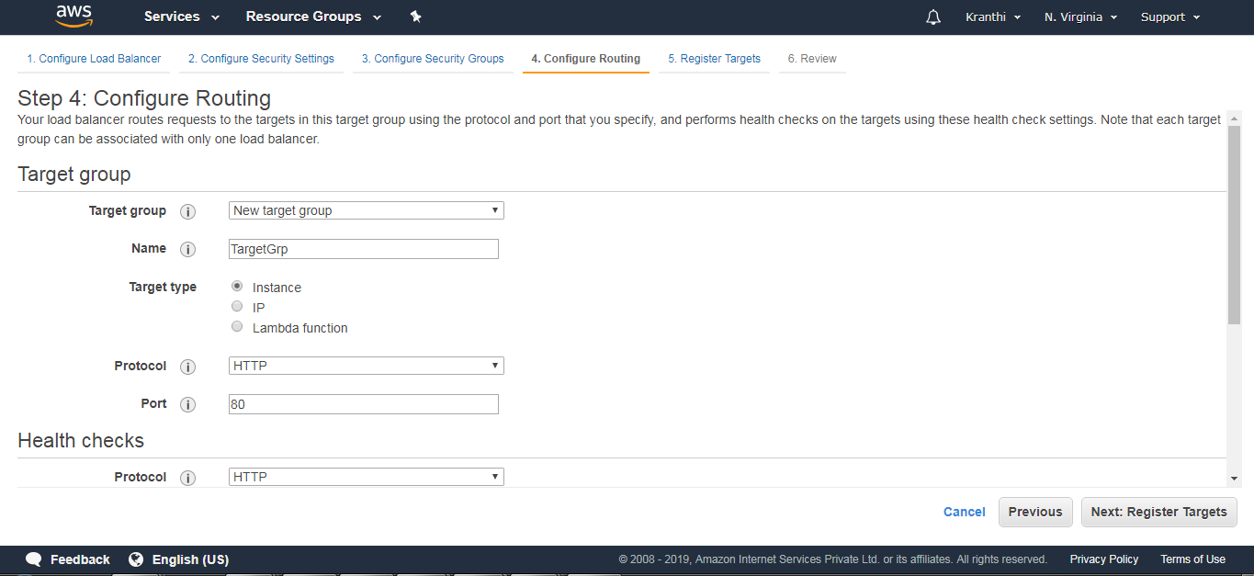

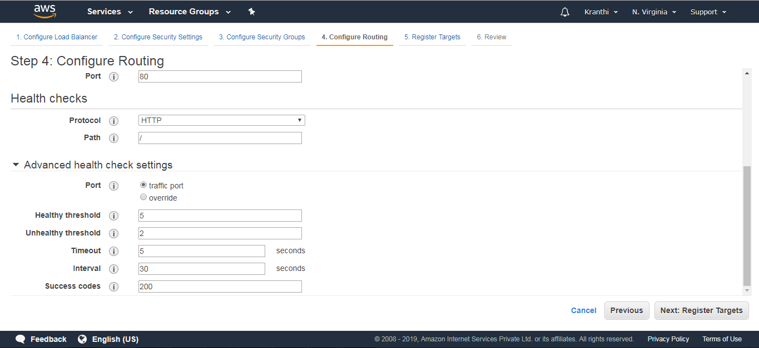

**Step 8:** Register Targets (nothing but EC2 instances that are created).

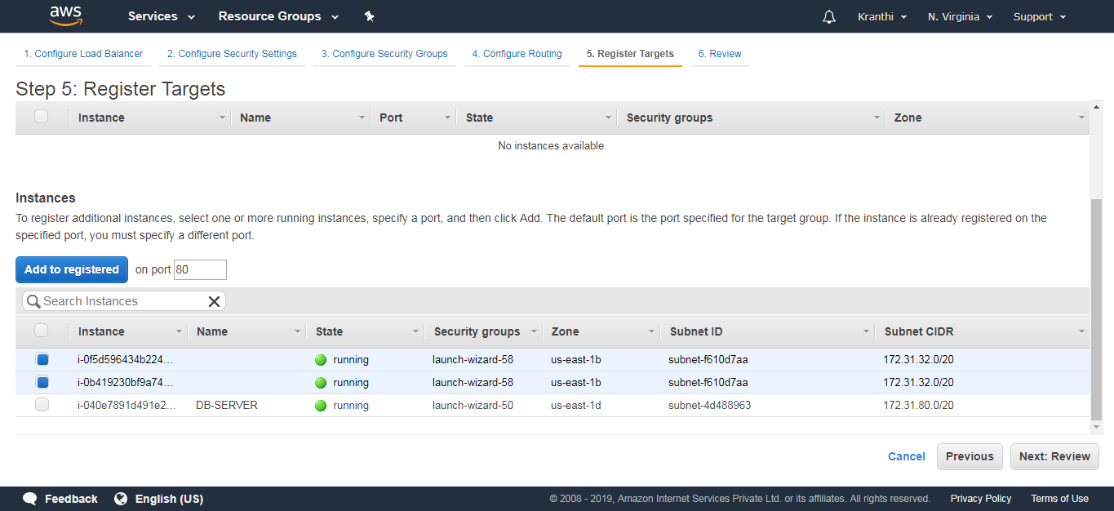

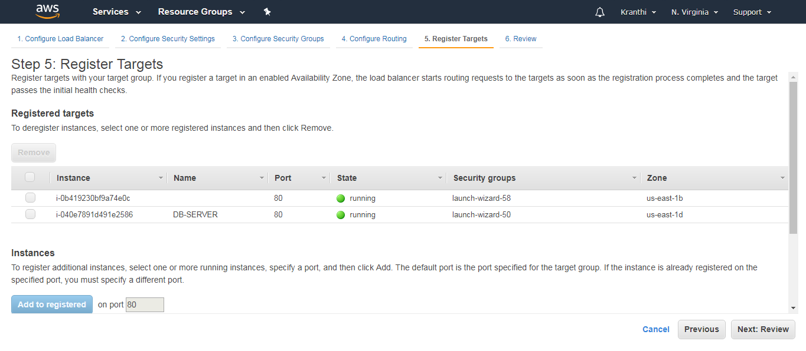

**Review:** View all the information of an Elastic Load Balancer.

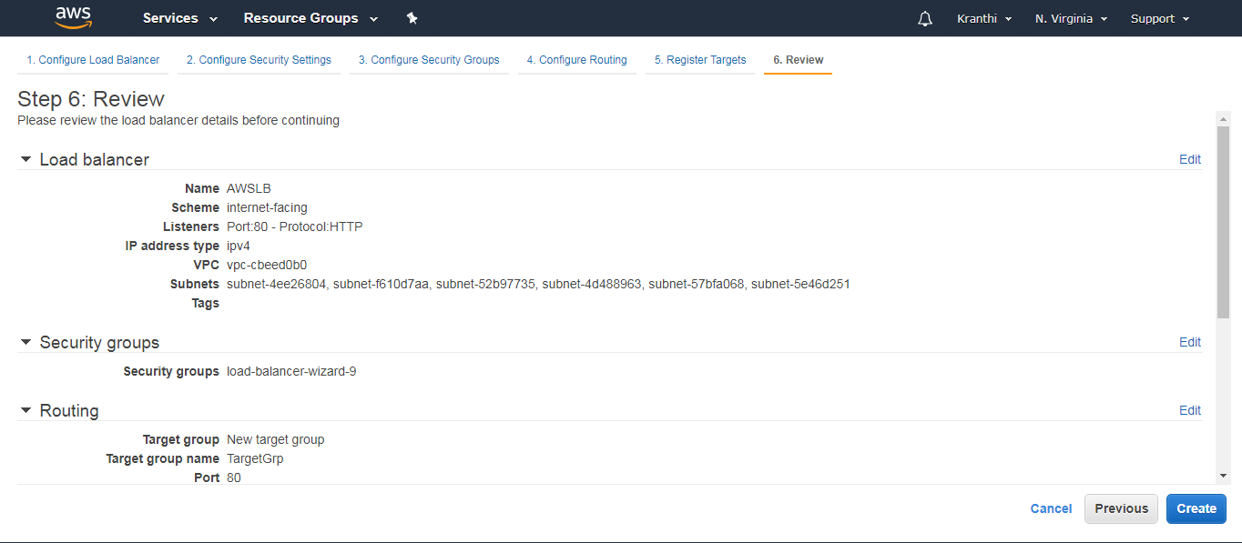

**Step 9:** We can now notice the notification that Load Balancer is created.

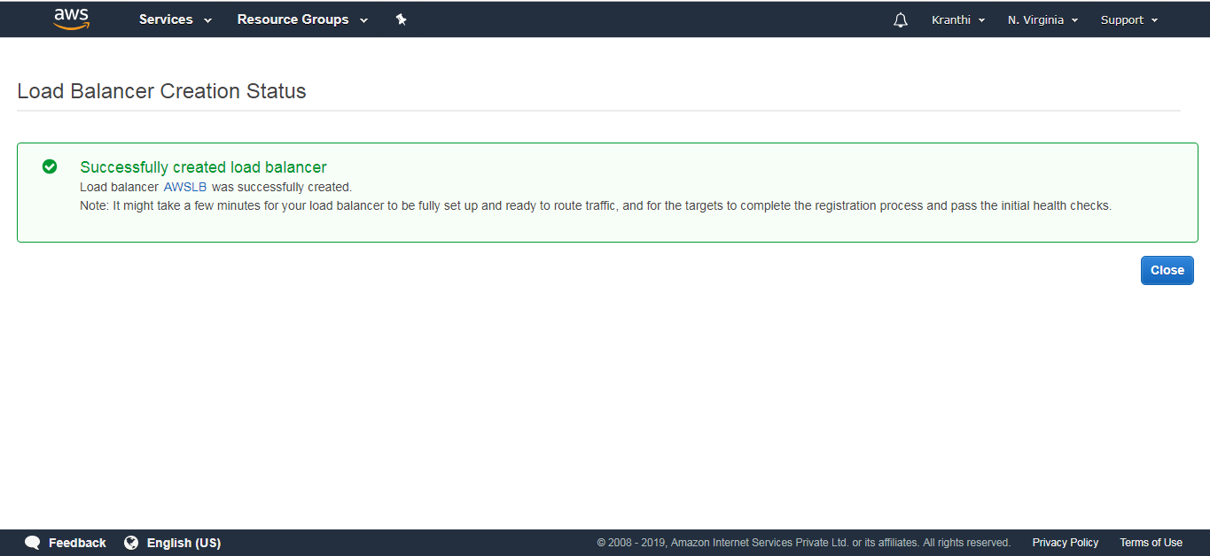

Check whether the web instances are healthy when added to a load balancer.

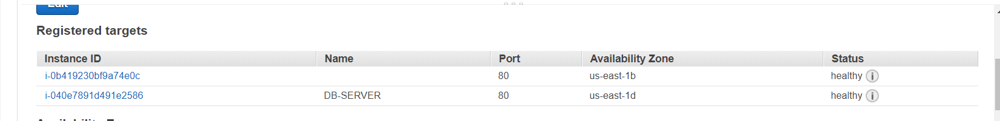

**Step 10:** This is the Load Balancer that we have created.

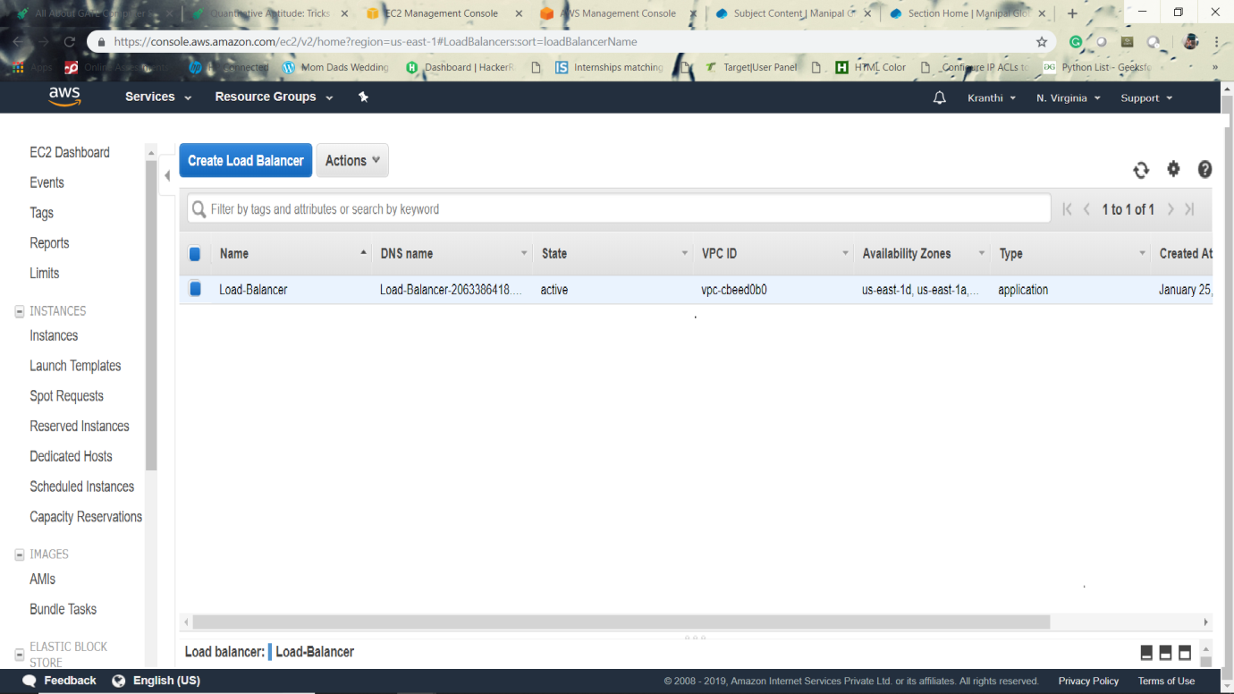

The web portal runs on a specified URL of Elastic Load Balancer

**5.3 AUTO SCALING**

**5.3.1 Introduction**

An Auto Scaling group contains a collection of Amazon EC2 instances that share similar characteristics and are treated as a logical grouping for the purposes of instance scaling and management. If you might want to increase the number of instances in that group to improve the performance of the application. Or, you can decrease the number of instances to reduce costs when demand is low. Use the Auto Scaling group to scale the number of instances automatically based on criteria that you specify. You could also maintain a fixed number of instances even if an instance becomes unhealthy. This automatic scaling and maintaining the number of instances in an Auto Scaling group is the core functionality of the Amazon EC2 Auto Scaling service.

There are two tasks to be followed for Auto-Scaling, they are

1. Create a launch template

2. Create Auto-Scaling group.

**5.3.2 Create a Launch Template**

To create a launch template for an Auto Scaling group

**Step 1:** Open the Amazon EC2 console.

**Step 2:** On the navigation bar, select a region. The Amazon EC2 Auto Scaling resources that you create are tied to the region you specify.

**Step 3:** On the navigation pane, choose Instances, Launch Templates.

**Step 4:** Choose Create launch template.

**Step 5:** Create Auto Scaling group.

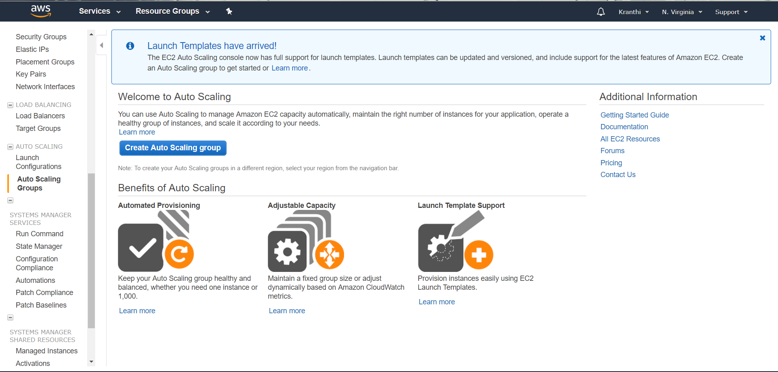

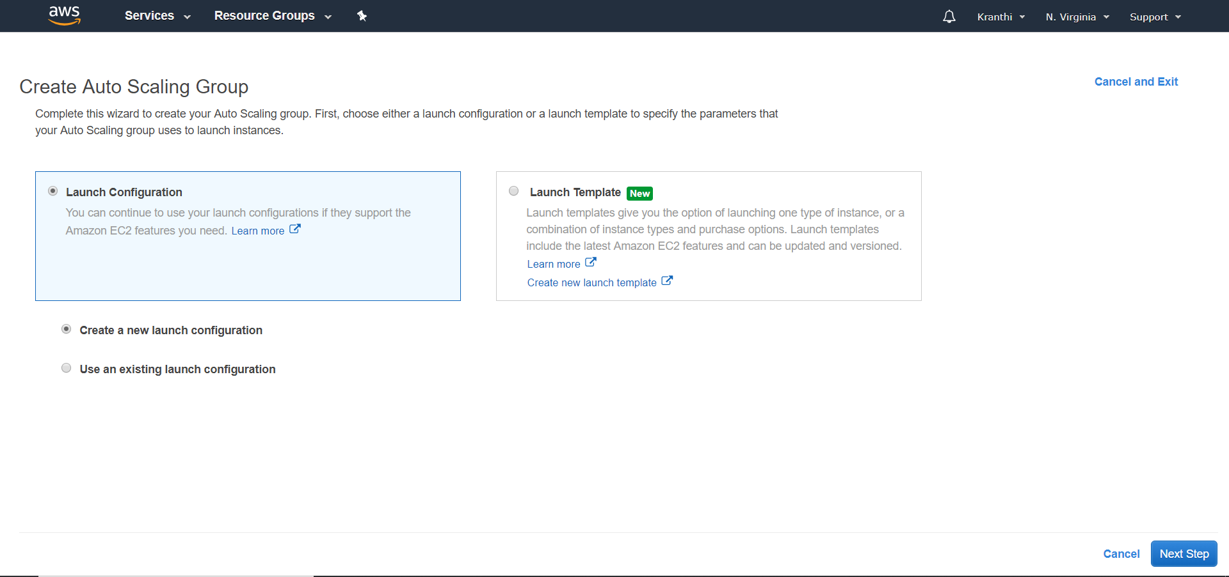

An AMI is a template that contains the software configuration to launch the instances.

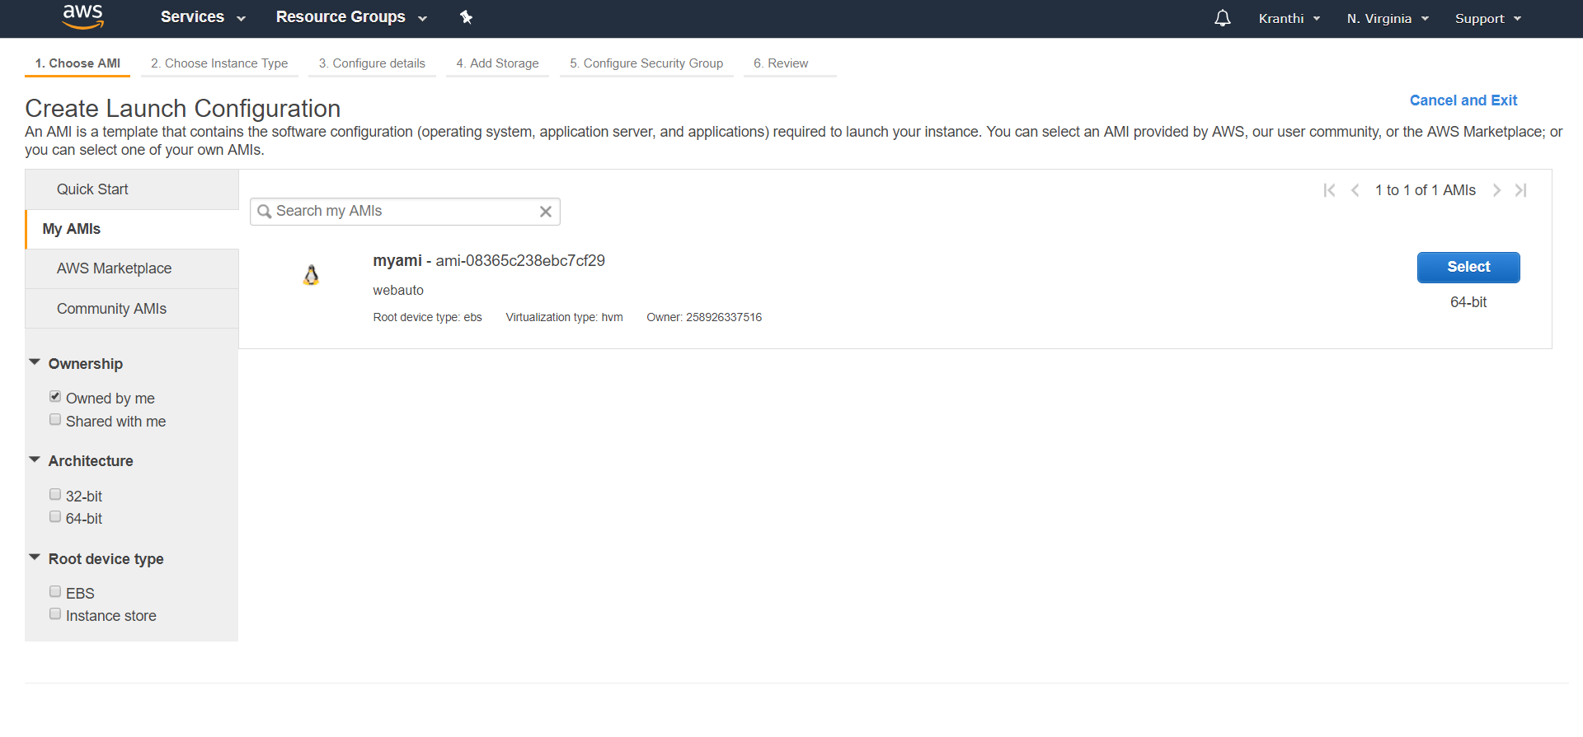

Configure the Launch configuration, set the name to display.

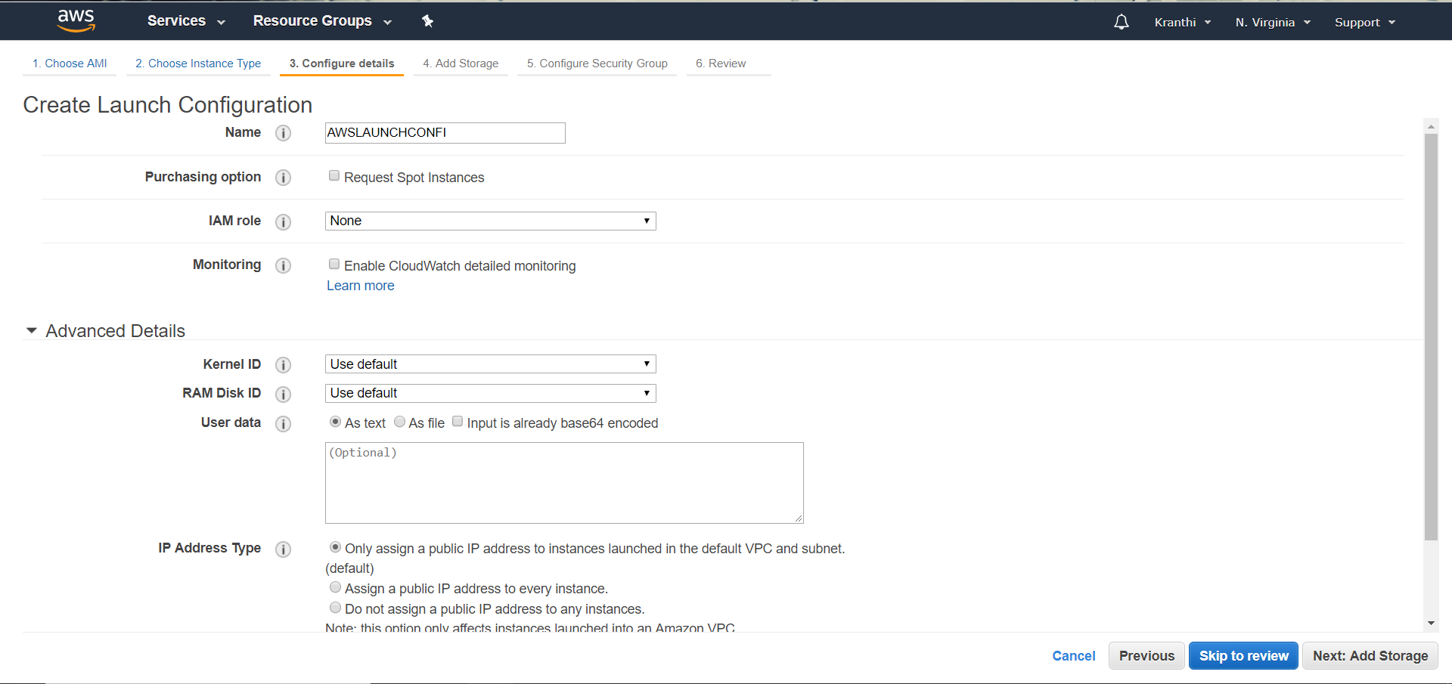`

Storage settings to your instance.

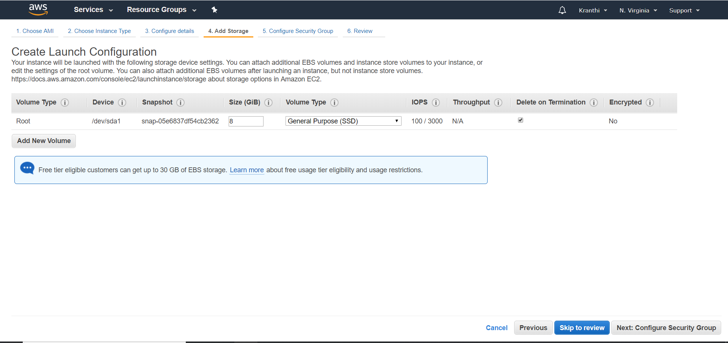

Configure security group and add own rules.

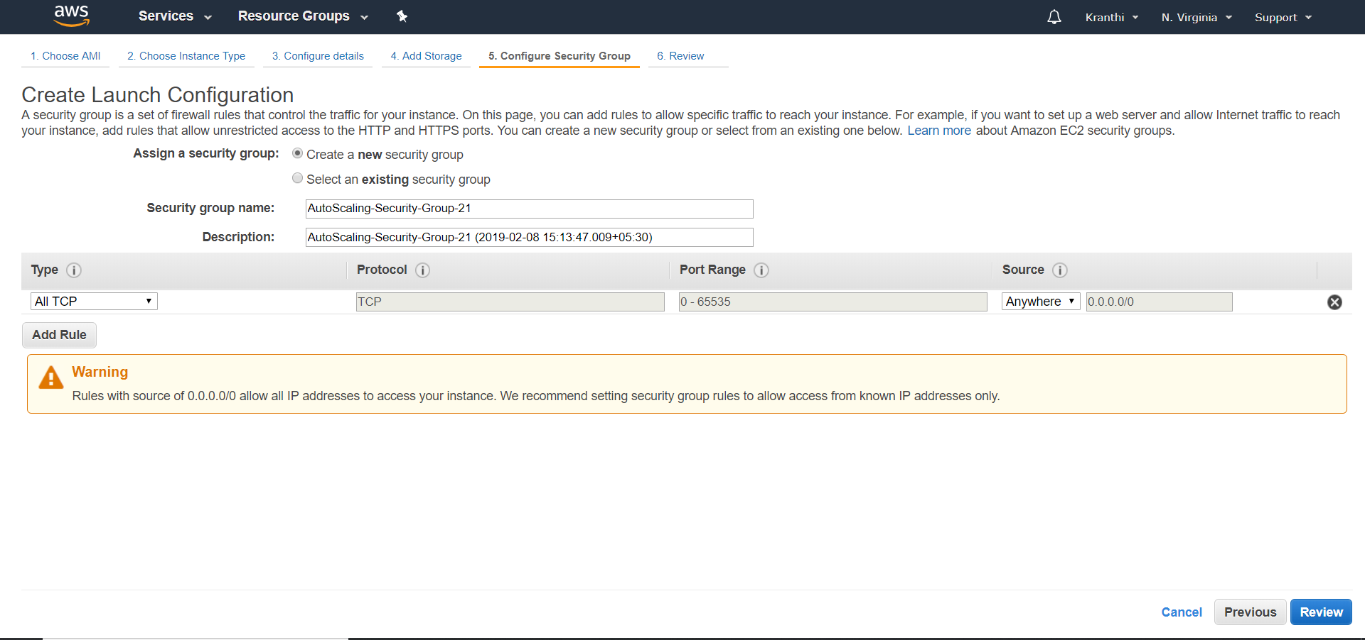

Review gives the total information about AMI.

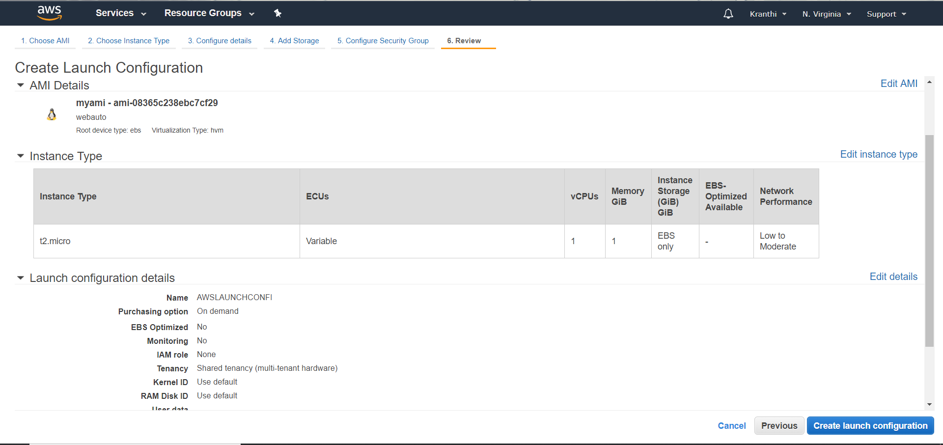

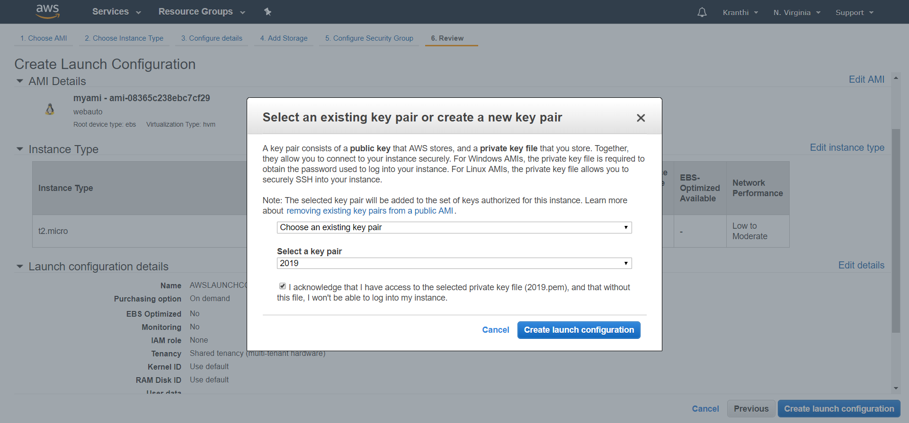

**5.3.3 Create Auto-Scaling groups**

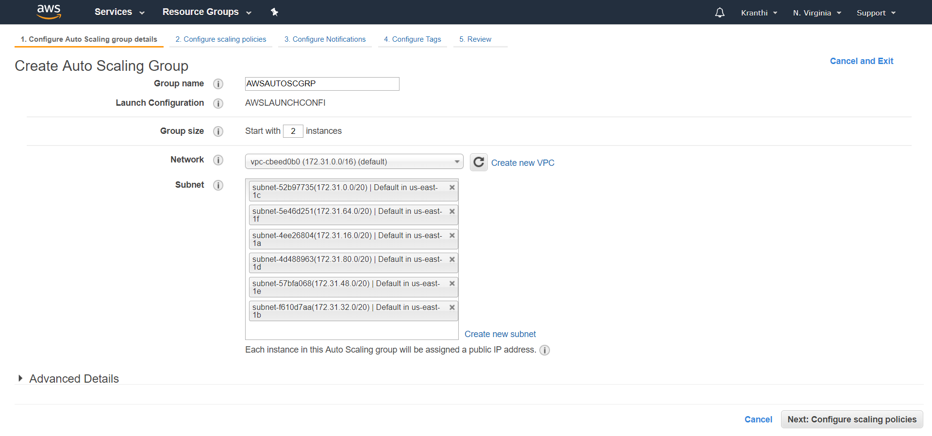

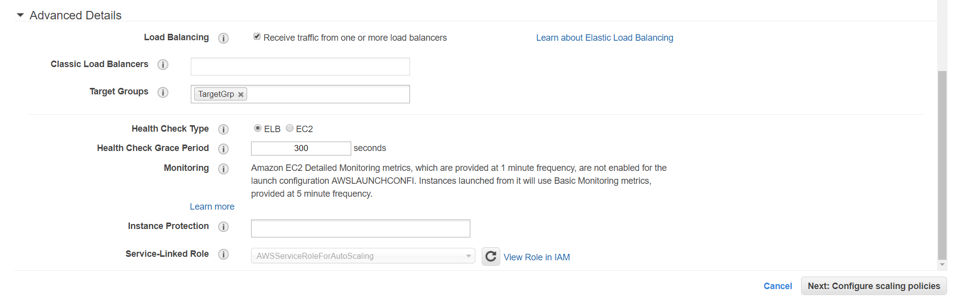

In this Auto-Scaling group, we need write how many instances we need to add when the avg-C.P.U percentages goes high or decrease.

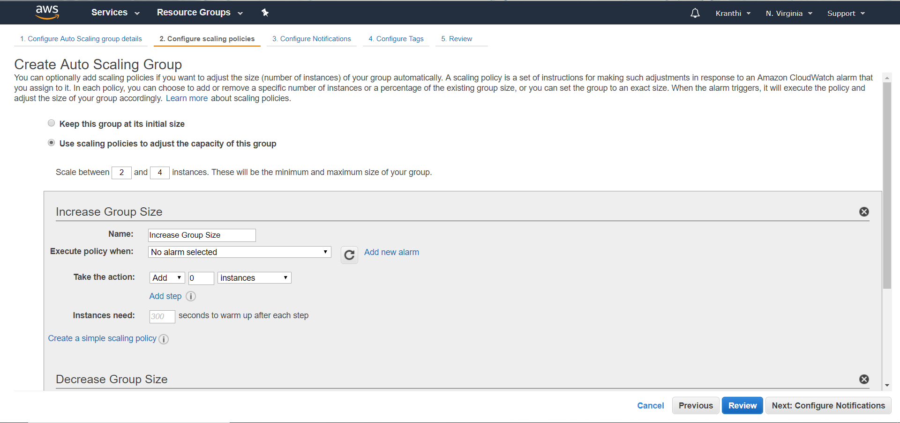

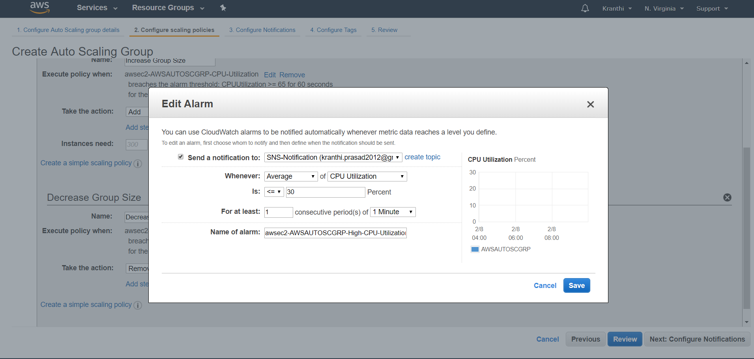

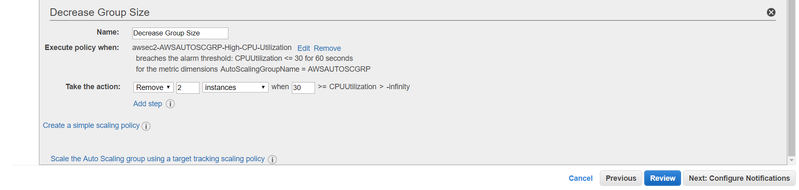

Reviews shows whatever we have added to the auto scaling group.

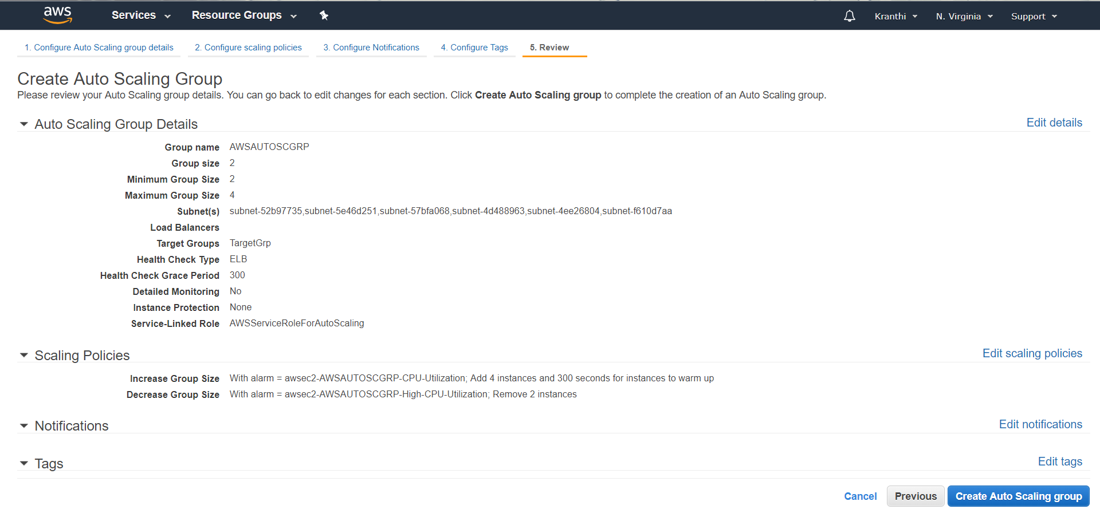

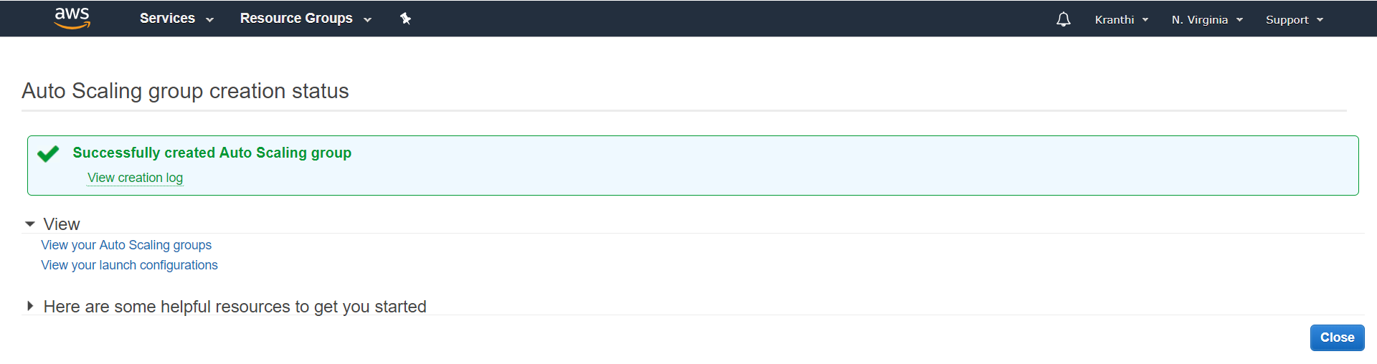

The complete adding of auto-scaling was finished and shows the added one.

**CHAPTER-6**

**NETWORK SECURITY**

**6.1 Introduction**

Network security consists of the policies and practices to prevent and monitor unauthorized access, misuse, modification, or denial of a computer network and network-accessible resources. Only Network security can protect you from Trojan horse viruses. Network security involves the authorization of access to data in a system, controlled by the network administrator.

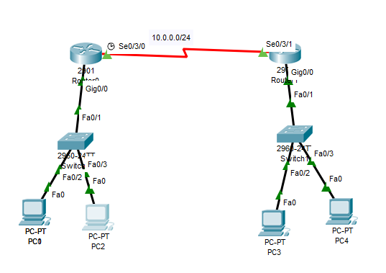

Fig 6.1: Network Topology

To avoid ARP SPOOFING, MAC FLOODING, and DHCP SPOOFING, we implement security policies. Firewall plays a preeminent role in network security. To prevent unauthorized access, we are using Cisco advanced security appliances. To connect different branches with security, we are implementing SITE TO SITE VPN. To overcome the network attacks, we are developing the Intrusion Prevention System. Cisco IOS Intrusion Prevention System (IPS) is an inline, deep-packet inspection feature that effectively mitigates a wide range of network attacks. These network security infrastructures are implementing in On-premises, not in a cloud.

**6.2 DHCP Snooping**

DHCP snooping is a security feature that acts like a firewall between untrusted hosts and Trusted DHCP Servers. The DHCP snooping feature performs the following activities:

* Validates DHCP messages received from untrusted sources and filters out invalid Messages.
* Rate-limits DHCP traffic from trusted and untrusted sources.
* Builds and maintains the DHCP snooping binding database, which contains information about untrusted hosts with leased IP addresses.
* Utilizes the DHCP snooping binding database to validate subsequent requests from Untrusted hosts.

**Step By Step Procedure For Implementing DHCP**

The following steps are required to implement DHCP snooping on your network:

**Step 1:** Define and configure the DHCP server. Configuration of this step does not take

Place on the switch or router and is beyond the scope of this book.

**Step 2:** Enable DHCP snooping on at least one VLAN. By default, DHCP snooping is

Inactive on all VLANs.

**Step 3:** Ensure that DHCP server is connected through a trusted interface. By default, the trust state of all interfaces is untrusted.

**Step 4:** Configure the DHCP snooping database agent. This step ensures that database Entries are restored after a restart or switchover.

**Step 5:** Enable DHCP snooping globally.

**Implementing DHCP on Switch**

Enable DHCP Snooping Globally

* sw2(config)# **ip dhcp snooping**
* Enable DHCP Snooping on VLAN 10
* sw2(config)# **ip dhcp snooping vlan 10**
* Configure Interface Fa1/0/24 as a trusted interface
* sw2(config)# **interface fa1/0/24**
* sw2(config-if)# **ip dhcp snooping trust**

Configure the DHCP snooping database agent to store the bindings at a given location

* sw2(config)# **exit**

sw2#

Verify DHCP Snooping Configuration

**Output**

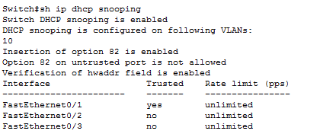

Fig 6.2: DHCP Snooping Output

**6.3 Port Security**

How many MAC addresses should legitimately show up inbound on an access port? Port security controls how many MAC addresses can be learned on a single switch port. This feature is implemented on a port-by-port basis. A typical user uses just a single MAC Address. Exceptions to this may be a virtual machine or two that might use different MAC Addresses than their host, or if there is an IP phone with a built-in switch, which may also Account for additional MAC addresses.

In any case, to avoid a user connecting dozens of devices to a switch that is then connected to their access port, you can use port security to limit the number of devices (MAC addresses) on each port.

This also protects against malicious applications that may be sending thousands of frames Into the network, with a different bogus MAC address for each frame, as the user tries to Exhaust the limits of the dynamic MAC address table on the switch, which might cause the Switch to forward all frames to all ports within a VLAN so that the attacker can begin to Sniff all packets. This is referred to as a *CAM table overflow attack*. *Content-addressable* Memory *(CAM)* is a fancy way to refer to the MAC address table on the switch.

**Implementing Port-Security on Switch**

* SW2(config-if)# **interface fa 0/2**

! Enable the feature per interface

* SW2(config-if)# **switchport port-security**

! Set the maximum to desired number. Default is 1. If we administratively

! set the maximum to 1, the command won't show in the running configuration

! because the configuration matches the default value. It is handy to know

! this behavior, so you won't be surprised by what may seem to be a missing

! part of your configuration.

* SW2(config-if)# **switchport port-security maximum 5**

! Set the violation action. Default is err-disable. Protect will simply

! not allow

! frames from MAC addresses above the maximum.

* SW2(config-if)# **switchport port-security violation protect**

This will cause the dynamic mac addresses to be placed into running

! -config to save them to startup config, use copy run start

* SW2(config-if)# **switchport port-security mac-address sticky**

! To verify settings, use this command

**Output:**

Switch#sh port-security

Secure Port MaxSecure Addr CurrentAddr Security Violation Security Action

(Count) (Count) (Count)

--------------------------------------------------------------------

Fa0/2 5 1 0 Protect

Fa0/3 5 1 0 Protect

----------------------------------------------------------------------

Switch#

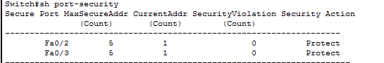

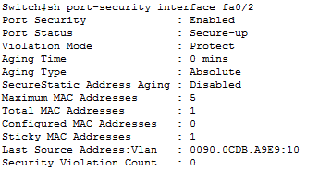

Fig 6.3: Port Security Output

**6.4 Securing the Cisco IOS Image and Configuration Files**

If a router has been compromised, and the flash file system and NVRAM have been deleted, then there could be significant downtime as the files are put back in place before restoring normal router functionality. The Cisco Resilient Configuration feature is intended to improve the recovery time by making a secure working copy of the IOS image and start up configuration files (which are referred to as the *primary* boot set) that cannot be deleted by a remote user. To enable and save the primary boot set to a secure archive in persistent storage, follow Secure the IOS image

* R6(config)# **secure boot-image**

%IOS_RESILIENCE-5-IMAGE_RESIL_ACTIVE: Successfully secured running image

! Secure the startup-config

* R6(config)# **secure boot-config**

%IOS_RESILIENCE-5-CONFIG_RESIL_ACTIVE: Successfully secured config archive

[flash:.runcfg-20111222-230018.ar]

! Verify the bootset

**Output**

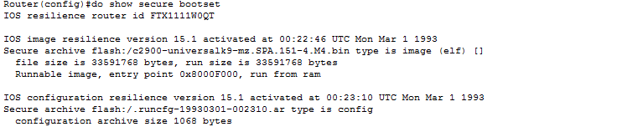

Fig 6.4 : Secured IOS Output

**6.5 ARP Dynamic Inspection**

ARP provides IP communication within a Layer 2 broadcast domain by mapping an IP Address to a MAC address. ARP spoofing attacks and ARP cache poisoning can occur because ARP allows a gratuitous reply from a host even if an ARP request was not received. After the attack, all traffic from the device under attack flows through the attacker’s computer and then to the router, switch, host.

An ARP spoofing attack can target hosts, switches, and routers connected to your Layer 2 network by poisoning the ARP caches of systems connected to the subnet and by intercepting traffic intended for other hosts on the subnet.

DAI is a security feature that validates ARP packets in a network. DAI intercepts, logs, andn Discards ARP packets with invalid IP-t o -MAC address bindings. This capability protects the Network from some man-in-the-middle attacks.

DAI determines the validity of an ARP packet based on valid IP-to-MAC address bindings

Stored in a trusted database, the DHCP snooping binding database. As described in the previous section, this database is built by DHCP snooping if DHCP snooping is enabled on the VLANs and on the switch. If the ARP packet is received on a trusted interface, the switch

Forward the packet without any checks. On untrusted interfaces, the switch forwards the packet only if it is valid.

Enable DAI on VLAN 10

* sw2(config)# **ip arp inspection vlan 10**
* sw2(config)# **exit**

! Verify DAI Configuration for VLAN 10

* sw2# **show ip arp inspection vlan 10**

Source Mac Validation : Disabled

Destination Mac Validation : Disabled

IP Address Validation : Disabled

Vlan Configuration Operation ACL Match Static ACL

---- ------------- --------- --------- ----------

10 Enabled Inactive

Vlan ACL Logging DHCP Logging Probe Logging

---- ----------- ------------ -------------

10 Deny Off

! Configure Interface Fa1/0/24 as a Trusted DAI Interface

* sw2(config)# **interface fa1/0/24**
* sw2(config-if)# **ip arp inspection trust**
* sw2(config-if)# **exit**
* sw2(config)# **exit**
* sw2# **show ip arp inspection interfaces**

Interface Trust State Rate (pps) Burst Interval

--------------- ----------- ---------- --------------

Fa1/0/1 Untrusted 15 1

Fa1/0/2 Untrusted 15 1

! output removed for brevity

Fa1/0/23 Untrusted 15 1

Fa1/0/24 Trusted None N/A

**6.6 Site to Site VPN**

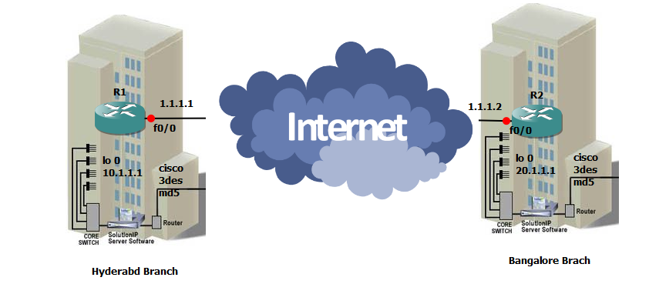

Fig 6.5: Site to Site VPN

It helps to connect two different branches or remote locations. It ensures that connectivity between two public networks and with security.

**Implementation Stages**

Phase 1: Internet security association key management protocols (ISAKMP).

Phase 2: Internet protocol security. It is having ESP and AH.

Phase 3: Interesting traffic will be configured by ACL.

Phase 4: Mapping (Crypto Map).

Phase 5: Apply map on interface.

Here Pre shared key will be used for trust worthiness between two branches.

**Encryption**

It will convert plain text into cipher text. It classified into 3 types.

1) DES-Data encryption standard

2) 3 DES

3) AES-Advanced encryption standard

**Hash:** It is used for checksum. It is having two types

1) MD5-Message Digest

2) SHA-Secure hashing Algorithm

**Ockley:** It is responsible to carry the message from Router 1 to Router 2.

If we are using both sites of routers are cisco vendors, then it is operated in main mode, in this 6 messages will be exchanged. For different vendors of router in both sites, it will be operated in Aggressive Mode only 3 messages exchanged.

In this VPN, we have 2 Tunnels. Those are

1) ISAKMP

2) IPSEC

**ISAKMP:** By using this tunnel session keys will be exchanged, this was generated by the **Diffie**–**Hellman** Algorithm. ISAKMP tunnel is responsible for IPSEC tunnel up and running.

**IPSEC:** This tunnel is used for actual data transmission. ESP and AH are responsible to carry data in IPSEC tunnel.

**Crypto Map:** It is used to identify the router the packet belongs to which network. Only one crypto map can be applied for single interface.

**HMac:** Hmac is used for sequence number and to add the Tags.

**5.6.1 VPN CONFIGURATION**

**Router-1**

* crypto isakmp policy 10
* encr 3des
* hash md5
* authentication pre-share
* group 2
* crypto isakmp key cisco address 1.1.1.2
* crypto isakmp key juniper address 1.1.1.3
* crypto ipsec transform-set dell esp-3des esp-md5-hmac
* crypto ipsec transform-set lenovo esp-aes esp-sha-hmac
* crypto map irfan 110 ipsec-isakmp
* set peer 1.1.1.2
* set transform-set dell
* match address 101
* crypto map irfan 111 ipsec-isakmp
* set peer 1.1.1.3
* set transform-set lenovo
* match address 102
* interface Loopback0
* ip address 10.1.1.1 255.0.0.0
* interface FastEthernet0/0
* ip address 1.1.1.1 255.0.0.0
* duplex auto
* speed auto
* crypto map irfan
* interface FastEthernet0/1
* no ip address
* shutdown
* duplex auto
* speed auto
* ip route 0.0.0.0 0.0.0.0 FastEthernet0/0
* no ip http server
* no ip http secure-server
* access-list 101 permit ip host 10.1.1.1 host 20.1.1.1
* access-list 101 permit ip host 1.1.1.1 host 1.1.1.2
* access-list 102 permit ip host 10.1.1.1 host 30.1.1.1
* control-plane
* line con 0
* exec-timeout 0 0
* privilege level 15
* logging synchronous
* line aux 0
* exec-timeout 0 0
* privilege level 15
* logging synchronous
* line vty 0 4
* login
* End

**Router-2**

* crypto isakmp policy 10
* encr 3des
* hash md5
* authentication pre-share
* group 2
* crypto isakmp key cisco address 1.1.1.1
* crypto ipsec transform-set dell esp-3des esp-md5-hmac
* crypto map irfan 110 ipsec-isakmp
* set peer 1.1.1.1
* set transform-set dell
* match address 101
* interface Loopback0
* ip address 20.1.1.1 255.0.0.0
* interface FastEthernet0/0
* ip address 1.1.1.2 255.0.0.0
* duplex auto
* speed auto
* crypto map irfan
* interface FastEthernet0/1
* no ip address
* shutdown
* duplex auto
* speed auto
* ip route 0.0.0.0 0.0.0.0 1.1.1.1
* no ip http server
* no ip http secure-server
* access-list 101 permit ip host 20.1.1.1 host 10.1.1.1
* access-list 101 permit ip host 1.1.1.2 host 1.1.1.1
* control-planel!
* line con 0
* exec-timeout 0 0
* privilege level 15
* logging synchronous
* line aux 0
* exec-timeout 0 0
* privilege level 15
* logging synchronous
* line vty 0 4
* login
* End

**CHAPTER-7**

**RESULTS**



Fig 7.1: Main Website page



Fig 7.2: EC2 OUTPUT

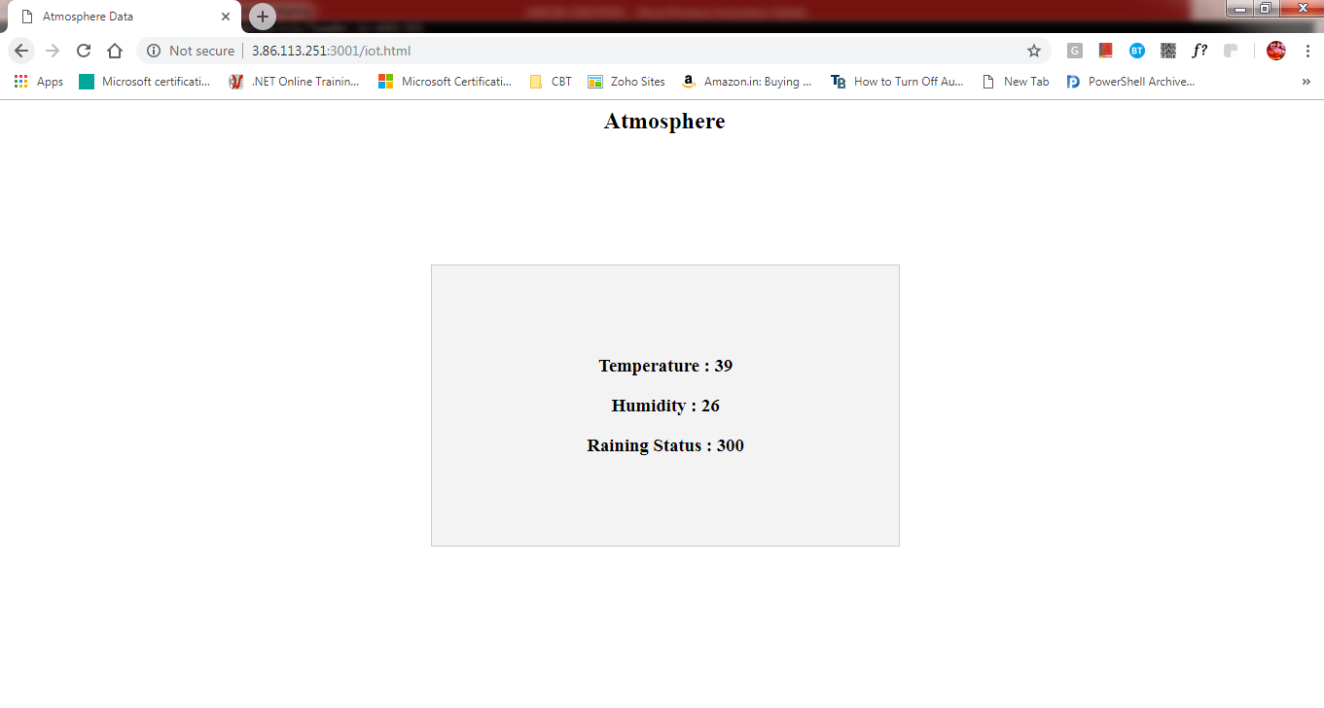

Fig 7.3: IoT Web Page

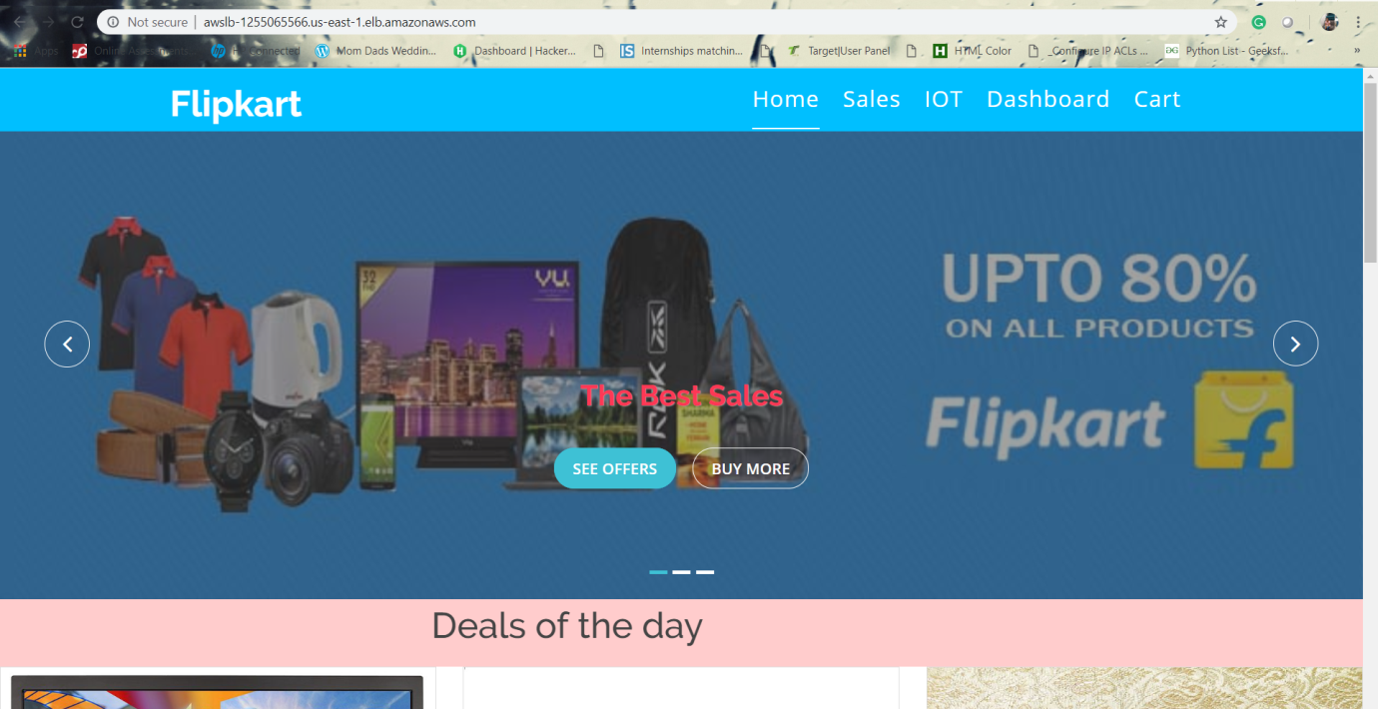

Fig 7.4: Load Balancer URL of website

We can notice the automatic addition of new instances, when CPU percentage goes high.

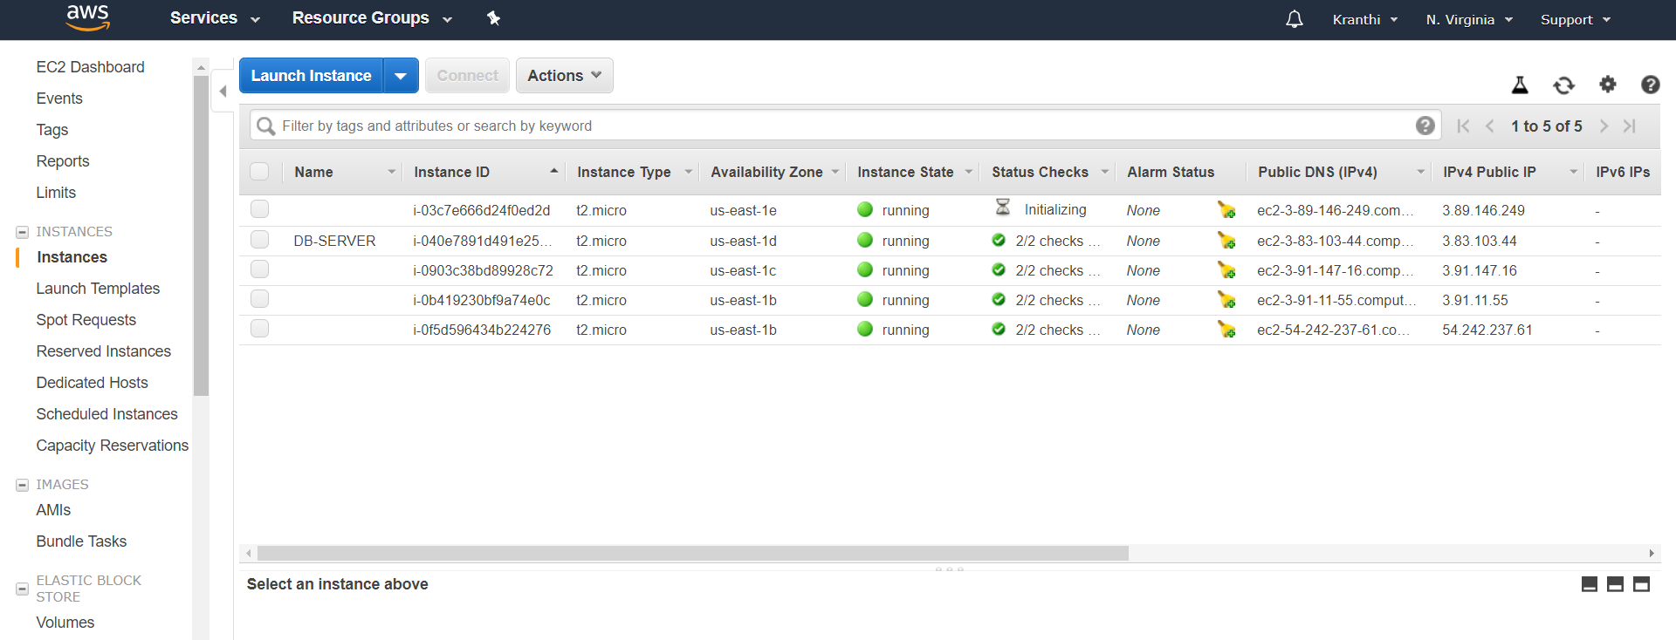

Fig 7.5: Auto Scale in Output

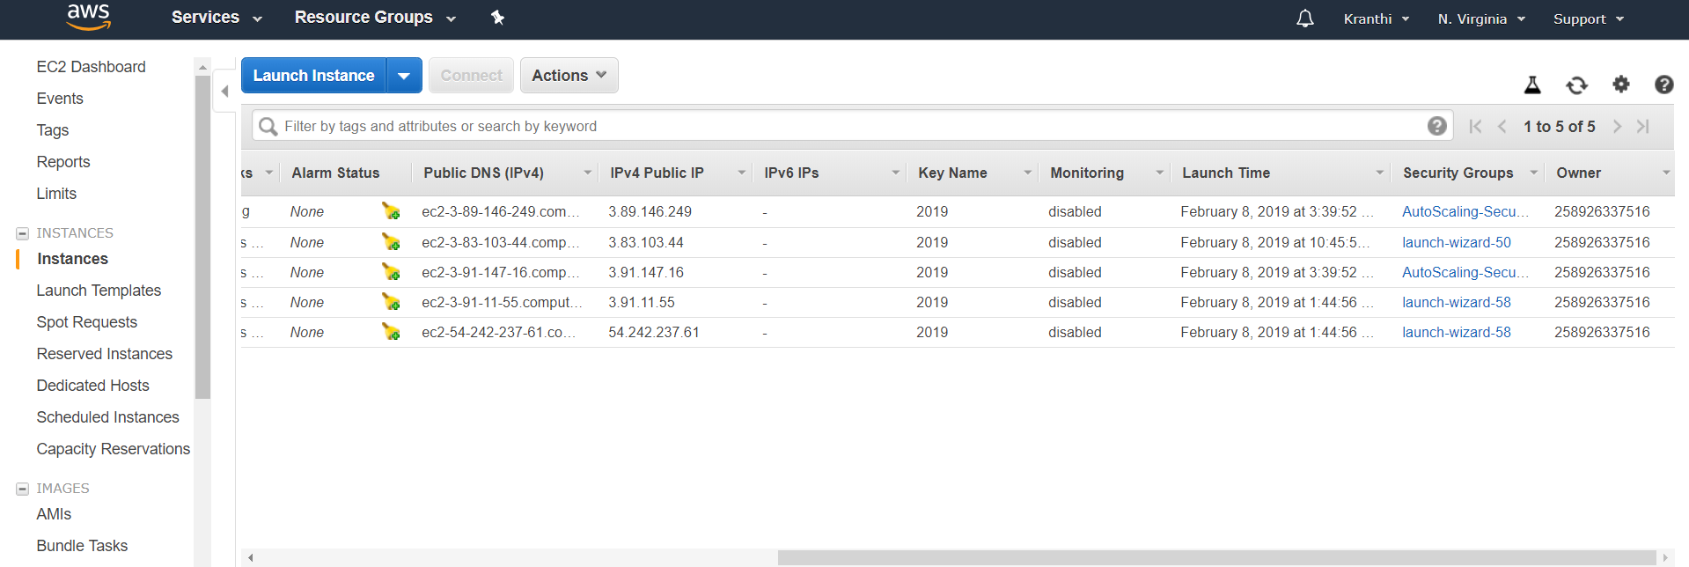

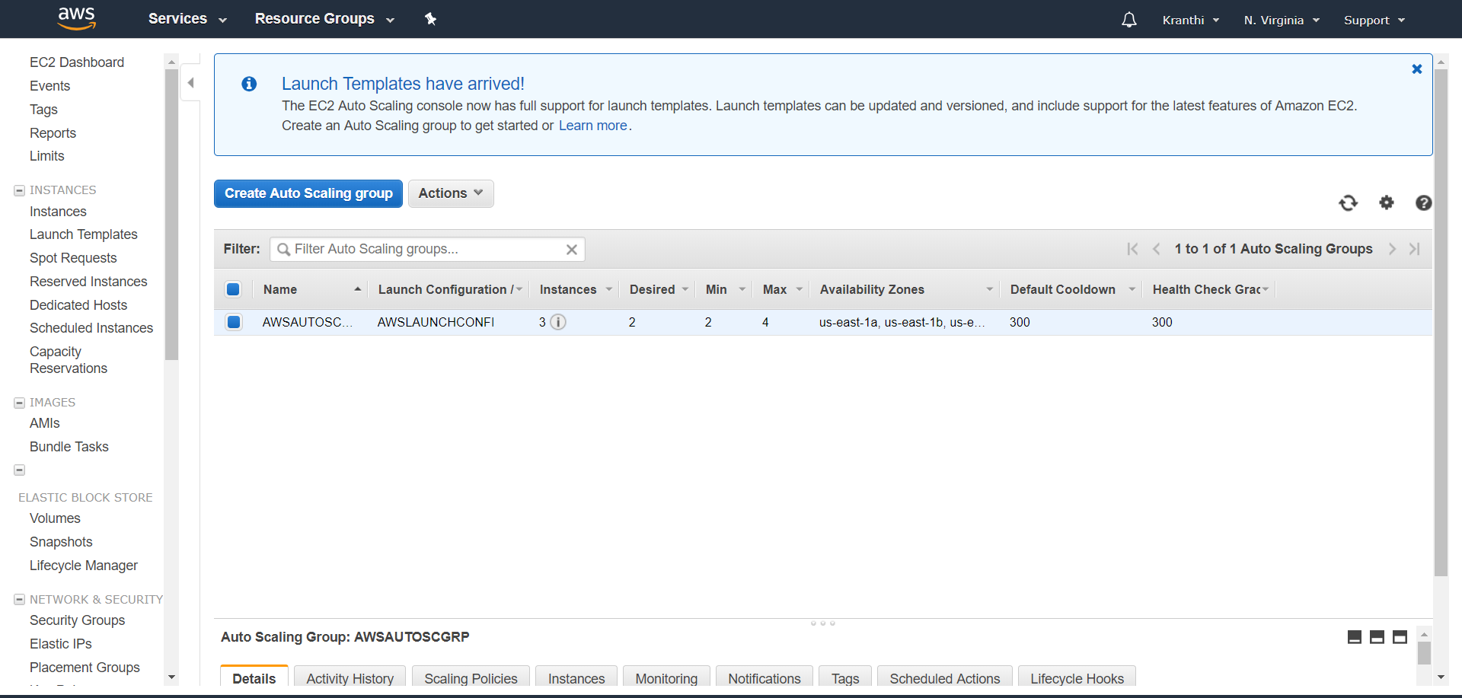

Termination of instances when the C.P.U percentage goes down.

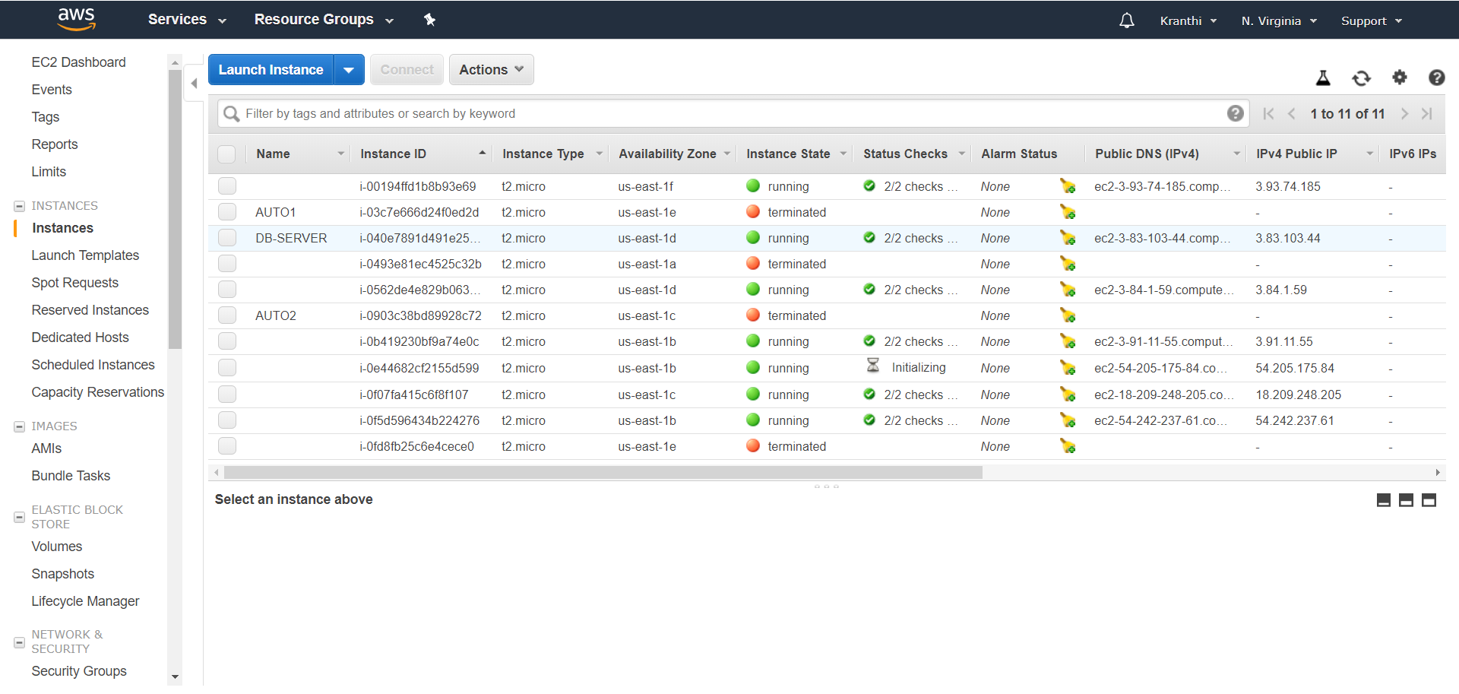

Fig 7.6: Auto Scale Out

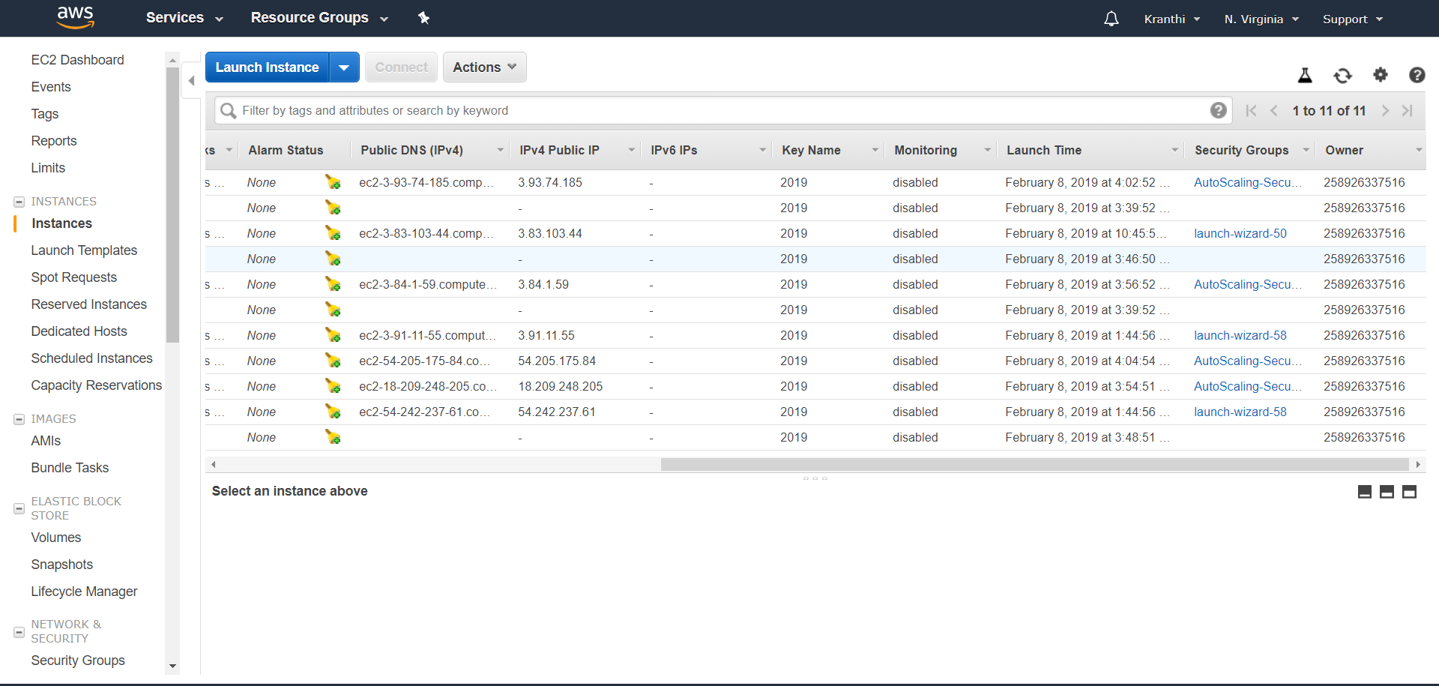

Fig 7.7: Auto Scale Final Output

**Output:**



Fig 7.8: DHCP Snooping Output

Switch#





Fig 7.9: Port Security Output



Fig 7.10: Secured IOS Output

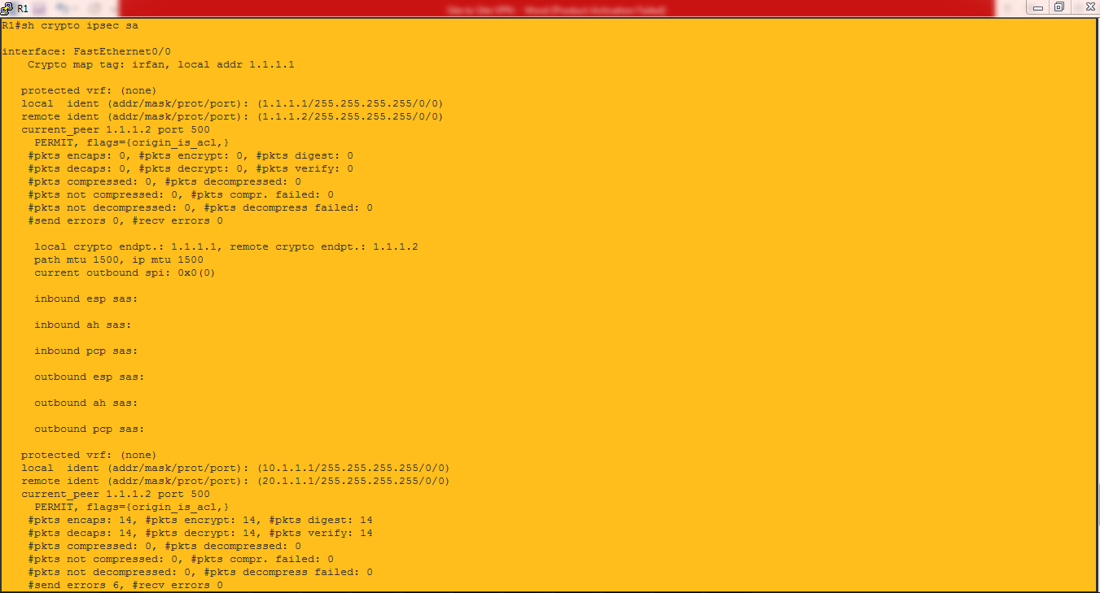

Fig 7.11: VPN Output

**CHAPTER-8**

**CONCLUSION AND FUTURE SCOPE**

**8.1 CONCLUSION**

The main theme of our project is to maintain the web applications run without any down time even when the number of users using the application is more may be in billions. AWS provides auto scaling that is, addition of new servers that maintains the same web application details when the C.P.U percentage gets increased and deleting the newly created servers when the usage is normal and load balancing features, By using these services provided by AWS, it costs less while compared to maintaining the physical servers, payable as per our usage, monitored 24/7 without any down time.

Using IOT sensors we can get the information regarding Atmosphere details such as Temperature, Humidity, Raining Status.

Finally, It’s clear to understand and design networked systems that are both robust to variations in the components and secured networks. We have provided some security features in On-Premises such as PORT-SECURITY, DHCP Snooping, SITE-To-SITE-VPN, Securing Cisco IOS and Configurations. Leaving the default configurations may cause cyber-attacks so preventing our infrastructure from these attacks proves to be a well secured network.

**8.2 FUTURE SCOPES**

Our project can be very useful for those who are new to this digital world, who wants to establish a new e-commerce website and wants to deploy every possible security for the website including load balancing and Auto scaling. Beside this it’s very useful for the people who don’t know about MySQL or database its security and implementation of these.

Hence its will be surely be recognized one day as a main step for developing website for an individual and throughout IOT project we can also make our website connected with IOT devices.

Developing big e-commerce website or any multimedia streaming website or any web related project can be made by just deploying with better security for any individual. It could also be used in Colleges, Universities or any other sector.

Eg: DB Migration & IPS

**REFERENCES**

[1] Techopedia.com, 'What is the Internet of Things (IoT)? - Definition from Techopedia', 2015. [Online]. Available: https://www.techopedia.com/definition/28247/internet-of-things-iot.

[2] C. Riley, 'Machine Data for End-to-End IoT System Monitoring', Blog.logentries.com, 2015. [Online]. Available: https://blog.logentries.com/2015/02/machine-data-for-end-to-end-iot-system-monitoring/.

[3] J. Gubbi, R. Buyya, S. Marusic and M. Palaniswami, 'Internet of Things (IoT): A vision, architectural elements, and future directions', Future Generation Computer Systems, vol. 29, no. 7, pp. 1645-1660, 2013

[4] Sparkfun.com, 'WiFi Module - ESP8266 - WRL-13678 - SparkFun Electronics', 2015. [Online] Available:https://www.sparkfun.com/products/13678.

[5] https://docs.aws.amazon.com/#lang/en_us

[6] https://www.netacad.com/

[7] https://hackernoon.com/tutorial-creating-and-managing-a-node-js-server-on-aws-part-1-d67367ac5171k

[8] https://websiteforstudents.com/install-the-latest-node-js-and-nmp-packages-on-ubuntu-16-04-18-04-lts/

[9] https://stackoverflow.com/questions/17666249/how-to-import-an-sql-file-using-the-command-line-in-mysql

**APPENDIX**

**Table Values**

Resources to create db:

User.sql=>contains the sql table creation and data to be inserted into created table

create table atmospheretable(

id int auto_increment,

temperature smallint,

humidity smallint,

created_time datetime,

raining_value smallint unsigned,

PRIMARY KEY(id)

);

create table productdetailtable(

id int auto_increment,

fullname varchar(200),

color varchar(50),

mrp smallint,

discount smallint,

brand varchar(50),

waranty smallint,

podavailable boolean,

replaceperiod smallint,

category varchar(50),

PRIMARY KEY(id)

);

**Connecting database to website**

**Node index.js (Main java script file for )**

const express = require('express'); // express driver installation

const app = express();

const mysql = require('mysql'); //mysql driver installation

const dbcon = mysql.createConnection({

'host':'localhost', //creating a connection to a database

'port':3306,

'user':'root',

'database':'atmospheredb'

});

app.use(express.json());

app.use(express.static('public'));

dbcon.connect(function(err,res){

if(err) {

console.log("err",err);

}else{

console.log("success");

}

});

app.get('/api/getdata', function(req,res){//

getData(req, res);

});

app.post('/api/putdata', function(req,res){

putData(req.body, res);

});

function getData(req,res){

dbcon.query('select * from atmospheretable order by created_time desc limit 1;',function(error,result){

if(error)

{

res.send(error);

}else

{

res.send(result.length?result[0]:result);

}

});

}

//insert into atmosphere tables the values

function putData(req,res){

dbcon.query('insert into atmospheretable (temperature,humidity,created_time) values (?,?,now()) ;',[req.temperature,req.humidity],function(error,result){

if(error) {

res.send(error);

}else {

res.send(result.length?result[0]:result);

}

});

}

app.listen(3001, () => console.log('Server running on port 3001')); //acknowledgement to the user that server is running.

**MQTT setup**

import ast

import paho.mqtt.client as mqtt

import ConfigParser

import simplejson as json

import logging

import datetime

import pymysql

LOG_FILENAME = 'FeedbackServer.log'

logging.basicConfig(filename=LOG_FILENAME,level=logging.DEBUG,format='%(asctime)s, %(levelname)s, %(message)s', datefmt='%Y-%m-%d %H:%M:%S')

class MQtt:

def __init__(self,host,port,subTopic,cur,db,timealive=60):

self.host = host

self.port = port

self.timealive = timealive

self.payload = None

self.subTopic = subTopic

self.pubTopic = "feedback-serv"

self.cur = cur

self.db = db

def __on_connect(self,client, userdata, flags, rc):

try:

print "Connected with result code "+str(rc)

if self.subTopic!=None:

(result,mid)= client.subscribe(self.subTopic)

print result

except Exception as e:

logging.error("The on_connect error %s,%s"%(e,type(e)))

def __on_message(self,client, userdata, msg):

try:

data = msg.payload

message = ast.literal_eval(data)

temperature = int(message["temperature"])

humidity = int(message["humidity"])

print temperature,humidity

insertStatement = "INSERT INTO atmospheretable (id,temperature,humidity,created_time) VALUES (default,"+str(temperature)+","+str(humidity)+",now());"

print insertStatement

try:

self.cur.execute(insertStatement)

except Exception as e:

print e

except Exception as e:

print e

logging.error("The on_message error %s,%s"%(e,type(e)))

def connect(self):

try:

self.mqttc = mqtt.Client()

self.mqttc.on_connect = self.__on_connect

self.mqttc.on_message = self.__on_message

self.mqttc.connect(self.host,self.port,self.timealive)

if self.subTopic != None:

print "Hu"

self.mqttc.loop_start()

self.mqttc.loop_forever()

except Exception as e:

logging.error("The connect error %s,%s"%(e,type(e)))

def send(self,message):

try:

(result,mid) = self.mqttc.publish(self.pubTopic,message,2)

return result

except Exception as e:

print e

logging.error("The send error %s,%s"%(e,type(e)))

if __name__ == '__main__':

# Mysql details

host = "localhost"

database = "atmospheredb"

table = "atmospheretable"

db = pymysql.connect(host="localhost",db="atmospheredb",autocommit=True)

cur = db.cursor()

# MQTT DETIALS

host = "18.232.46.180"

port = 1883

subTopic = "dht-resp"

mq = MQtt(host,port,subTopic,cur,db)

mq.connect()

**Storing Atmosphere Details into Database table**

import pymysql

import time

host = "localhost"

db = pymysql.connect(host="localhost",db="atmospheredb",autocommit=True)

cur = db.cursor()

temperature = 64

humidity = 36

print temperature,humidity

insertStatement = "INSERT INTO atmospheretable (id,temperature,humidity,created_time) VALUES (default,"+str(temperature)+","+str(humidity)+",now());"

print insertStatement

try:

cur.execute(insertStatement)

time.sleep(10)

except Exception as e:

print e

sqlQuery = "select * from atmospheretable;"

#Fetch all the rows - for the SQL Query

cur.execute(sqlQuery)

rows = cur.fetchall()

for row in rows:

print(row)

**Html code for our website**

<!doctype html>

<html lang="en">

<head>

<meta charset="utf-8">

<title>Commercial</title>

<meta content="width=device-width, initial-scale=1.0" name="viewport">

<meta content="" name="keywords">

<meta content="" name="description">

<!-- Favicons -->

<link href="img/img1.jpg" rel="icon">

<!-- Google Fonts -->

<link href="https://fonts.googleapis.com/css?family=Open+Sans:300,400,400i,600,700|Raleway:300,400,400i,500,500i,700,800,900" rel="stylesheet">

<!-- Bootstrap CSS File -->

<link href="lib/bootstrap/css/bootstrap.min.css" rel="stylesheet">

<!-- Libraries CSS Files -->

<link href="lib/nivo-slider/css/nivo-slider.css" rel="stylesheet">

<link href="lib/owlcarousel/owl.carousel.css" rel="stylesheet">

<link href="lib/owlcarousel/owl.transitions.css" rel="stylesheet">

<link href="lib/font-awesome/css/font-awesome.min.css" rel="stylesheet">

<link href="lib/animate/animate.min.css" rel="stylesheet">

<link href="lib/venobox/venobox.css" rel="stylesheet">

<!-- Nivo Slider Theme -->

<link href="css/nivo-slider-theme.css" rel="stylesheet">

<!-- Main Stylesheet File -->

<link href="css/style.css" rel="stylesheet">

<!-- Responsive Stylesheet File -->

<link href="css/responsive.css" rel="stylesheet">

<style>

.grid-container {

display: grid;

grid-template-columns: auto auto auto auto;

grid-gap: 10px;

background-color:hsl(0, 100%, 90%);;

padding: 10px;

}

}

</style>

</head>

<body data-spy="scroll" data-target="#navbar-example">

<div id="preloader"></div>

<header>

<!-- header-area start -->

<div id="sticker" class="header-area">

<div class="container">

<div class="row">

<div class="col-md-12 col-sm-12">

<!-- Navigation -->

<nav class="navbar navbar-default">

<!-- Brand and toggle get grouped for better mobile display →

<div class="navbar-header">

<button type="button" class="navbar-toggle collapsed" data-toggle="collapse" data-target=".bs-example-navbar-collapse-1" aria-expanded="false">

<span class="sr-only">Toggle navigation</span>

<span class="icon-bar"></span>

<span class="icon-bar"></span>

<span class="icon-bar"></span>

</button>

<!-- Brand -->

<a class="navbar-brand page-scroll sticky-logo" href="index.html">

<h1>Flipkart</h1>

<!-- Uncomment below if you prefer to use an image logo -->

<!-- <img src="img/logo.png" alt="" title=""> -->

</a>

</div>

<!-- Collect the nav links, forms, and other content for toggling -->

<div class="collapse navbar-collapse main-menu bs-example-navbar-collapse-1" id="navbar-example">

<ul class="nav navbar-nav navbar-right">

<li class="active">

<a class="page-scroll" href="#home">Home</a>

</li>

<li>

<a class="page-scroll" href="#about">Sales</a>

</li>

<li>

<a class="page-scroll" href="iot.html">IOT</a>

</li>

<li>

<a class="page-scroll">Dashboard</a>

</li>

<li>

<a class="page-scroll">Cart</a>

</li>

</ul>

</div>

<!-- navbar-collapse -->

</nav>

<!-- END: Navigation -->

</div>

</div>

</div>

</div>

<!-- header-area end -->

</header>

<!-- header end -->

<!-- Start Slider Area -->

<div id="home" class="slider-area">

<div class="bend niceties preview-2">

<div id="ensign-nivoslider" class="slides">

<img src="img/slider/img3.jpg" alt="" title="#slider-direction-1" />

<img src="img/slider/img4.png" alt="" title="#slider-direction-2" />

<img src="img/slider/img5.png" alt="" title="#slider-direction-3" />

</div>

<!-- End Slider Area -->

</div>

</div>

<!-- direction 1 -->

<div id="slider-direction-1" class="slider-direction slider-one">

<div class="container">

<div class="row">

<div class="col-md-12 col-sm-12 col-xs-12">

<div class="slider-content">

<!-- layer 1 -->

<div class="layer-1-1 hidden-xs wow slideInDown" data-wow-duration="2s" data-wow-delay=".2s">

<h2 class="title1" style="color:#FF3855; text-shadow:1px 1px 1px grey;">The Best Sales </h2>

</div>

<!-- layer 2 -->

<div class="layer-1-3 hidden-xs wow slideInUp" data-wow-duration="2s" data-wow-delay=".2s">

<a class="ready-btn right-btn page-scroll" href="#services">See Offers</a>

<a class="ready-btn page-scroll" href="#about">Buy More</a>

</div>

</div>

</div>

</div>

</div>

</div><!-- direction 2 -->

<div id="slider-direction-2" class="slider-direction slider-two">

<div class="container">

<div class="row">

<div class="col-md-12 col-sm-12 col-xs-12">

<div class="slider-content">

<!-- layer 1 -->

<div class="layer-1-1 hidden-xs wow slideInDown" data-wow-duration="2s" data-wow-delay=".2s">

<h2 class="title1" style="color:#1B1B1B; text-shadow:1px 1px 1px grey;">The Best Sales and Offers</h2>

</div>

<!-- layer 2 -->

<div class="layer-1-2 wow slideInUp" data-wow-duration="2s" data-wow-delay=".1s">

<h1 class="title2" style="color:#1B1B1B; text-shadow:1px 1px 1px grey;">Hurray It's a Big Billion Day</h1>

</div>

<!-- layer 3 -->

<div class="layer-1-3 hidden-xs wow slideInUp" data-wow-duration="2s" data-wow-delay=".2s">

<a class="ready-btn right-btn page-scroll" href="#services">See Offers</a>

<a class="ready-btn page-scroll" href="#about">Buy More</a>

</div>

</div>

</div>

</div>

</div>

</div>

<!-- direction 1 -->

<div id="slider-direction-3" class="slider-direction slider-three">

<div class="container">

<div class="row">

<div class="col-md-12 col-sm-12 col-xs-12">

<div class="slider-content">

<!-- layer 1 -->

<div class="layer-1-1 hidden-xs wow slideInDown" data-wow-duration="2s" data-wow-delay=".2s">

<h2 class="title1" style="color:#1B1B1B;">Great Indian Sales</h2>

</div>

</div>

</div>

</div>

</div>

</div>

<!-- Start sales Area -->

<div class="grid-container">

<div class="container text-center" >

<div class="row">

<h2>Deals of the day</h2>

<!--<button id="btn_click">view more</button!-->

</div>

</div>

</div>

<div class="row">

<div class="col-md-4 col-sm-3 col-xs-12">

<div class="single-team-member">

<a href="#">

<img src="img/sales/14.jpg" alt="">

</a>

<div class="team-social-icon text-center">

<ul>

<li>

<a href="#">

<i class="fa fa-gittip"></i>

</a>

</li>

</ul>

</div>

</div>

<div class="team-content text-center">

<h4>Technology in next level</h4>

<p>Offer today</p>

<p>₹5400 48%off</p>

</div>

</div>

<!-- End column -->

<!-- <div class="team-top"> -->

<div class="col-md-4 col-sm-3 col-xs-12">

<div class="single-team-member">

<a href="#">

<img src="img/sales/12.jpg" alt="">

</a>

<div class="team-social-icon text-center">

<ul>

<li>

<a href="#">

<i class="fa fa-gittip"></i>

</a>

</li>

</ul>

</div>

</div>

<div class="team-content text-center">

<h4>shoes & more</h4>

<p>₹690 60% off</p>

</div>

</div>

<!-- End column -->

<!-- <div class="team-top"> -->

<div class="col-md-4 col-sm-3 col-xs-12">

<div class="single-team-member">

<a href="#">

<img src="img/sales/13.jpg" alt="">

</a>

<div class="team-social-icon text-center">

<ul>

<li>

<a href="#">

<i class="fa fa-gittip"></i>

</a>

</li>

</ul>

</div>

</div>

<div class="team-content text-center">

<h4>Girls Fashion wear</h4>

<p>₹250 74% off</p>

</div>

</div>

</div>

<!-- End column -->

</div>

</div>

</div>

</div>

<!-- End Team Area -->

<!-- Start About area -->

<div id="about" class="about-area area-padding">

<div class="container">

<div class="row">

<div class="col-md-12 col-sm-12 col-xs-12">

<div class="section-headline text-center">

<h2>Great Sales and Exclusive Offers</h2>

</div>

</div>

</div>

<div class="row">

<!-- Start Portfolio -page -->

<div class="awesome-project-1 fix">

<div class="col-lg-12 col-md-12 col-sm-12 col-xs-12">

<div class="awesome-menu ">

<ul class="project-menu">

<li>

<a href="#" class="active" data-filter="*">All</a>

</li>

<li>

<a href="#" data-filter=".design">Acsessories</a>

</li>

<li>

<a href="#" data-filter=".photo">electronics</a>

</li>

</ul>

</div>

</div>

</div>

<div class="awesome-project-content">

<!-- single-awesome-project start -->

<div class="col-md-4 col-sm-4 col-xs-12 design development">

<div class="single-awesome-project">

<div class="awesome-img">

<a href="#"><img src="img/sales/kitchen.jpg" alt="" /></a>

<div class="add-actions text-center">

<div class="project-dec">

<a class="venobox" data-gall="myGallery" href="img/sales/kitchen.jpg">

<h4>Kitchen Items 50% off</h4>

</a>

</div>

</div>

</div>

</div>

</div>

<!-- single-awesome-project end -->

<!-- single-awesome-project start -->

<div class="col-md-4 col-sm-4 col-xs-12 design">

<div class="single-awesome-project">

<div class="awesome-img">

<a href="#"><img src="img/sales/winter.jpg" alt="" /></a>

<div class="add-actions text-center">

<div class="project-dec">

<a class="venobox" data-gall="myGallery" href="img/sales/winter.jpg">

<h4>Winter shopping</h4>

</a>

</div>

</div>

</div>

</div>

</div>

<!-- single-awesome-project end -->

<!-- single-awesome-project start -->

<div class="col-md-4 col-sm-4 col-xs-12 photo development">

<div class="single-awesome-project">

<div class="awesome-img">

<a href="#"><img src="img/sales/accessories.jpg" alt="" /></a>

<div class="add-actions text-center">

<div class="project-dec">

<a class="venobox" data-gall="myGallery" href="img/sales/accessories.jpg">

<h4>Gadgets</h4>

<span>On sales</span>

</a>

</div>

</div>

</div>

</div>

</div>

<!-- single-awesome-project end -->

<!-- single-awesome-project start -->

<div class="col-md-4 col-sm-4 col-xs-12 design">

<div class="single-awesome-project">

<div class="awesome-img">

<a href="#"><img src="img/sales/7.jpeg" alt="" /></a>

<div class="add-actions text-center">

<div class="project-dec">

<a class="venobox" data-gall="myGallery" href="img/sales/7.jpeg">

<h4>Fashion Week</h4>

<span>40% sales</span>

</a>

</div>

</div>

</div>

</div>

</div>

<!-- single-awesome-project end -->

<!-- single-awesome-project start -->

<div class="col-md-4 col-sm-4 col-xs-12 photo development">

<div class="single-awesome-project">

<div class="awesome-img">

<a href="#"><img src="img/sales/galaxy.jpg" alt="" /></a>

<div class="add-actions text-center">

<div class="project-dec">

<a class="venobox" data-gall="myGallery" href="img/sales/galaxy.jpg">

<h4>Galaxy</h4>

<span>On sales</span>

</a>

</div>

</div>

</div>

</div>

</div>

<!-- single-awesome-project end -->

<div class="col-md-4 col-sm-4 col-xs-12 design">

<div class="single-awesome-project">

<div class="awesome-img">

<a href="#"><img src="img/sales/2.jpg" alt="" /></a>

<div class="add-actions text-center">

<div class="project-dec">

<a class="venobox" data-gall="myGallery" href="img/sales/2.jpg">

<h4>Handbags and clutches</h4>

<span>30% OFF</span>

</a>

</div>

</div>

</div>

</div>

</div>

<!-- single-awesome-project end -->

<!-- single-awesome-project start -->

<div class="col-md-4 col-sm-4 col-xs-12 photo development">

<div class="single-awesome-project">

<div class="awesome-img">

<a href="#"><img src="img/sales/3.jpg" alt="" /></a>

<div class="add-actions text-center">

<div class="project-dec">

<a class="venobox" data-gall="myGallery" href="img/sales/3.jpg">

<h4>Redmi on sales</h4>

</a>

</div>

</div>

</div>

</div>

</div>

<!-- single-awesome-project end -->

</div>

</div>

</div>

</div>

<!-- awesome-portfolio end -->

<!-- our-skill-area start -->

<div class="our-skill-area fix hidden-sm">

<div class="test-overly"></div>

<div class="skill-bg area-padding-2">

<div class="container">

<!-- section-heading end -->

<div class="row">

<div class="skill-text">

<!-- single-skill start -->

<div class="col-xs-12 col-sm-3 col-md-3 text-center">

<div class="single-skill">

<div class="progress-circular">

<input type="text" class="knob" value="0" data-rel="85" data-linecap="round" data-width="175" data-bgcolor="#fff" data-fgcolor="#3EC1D5" data-thickness=".20" data-readonly="true" disabled>

<h3 class="progress-h4">New Year sales</h3>

</div>

</div>

</div>

<!-- single-skill end -->

<!-- single-skill start -->

<div class="col-xs-12 col-sm-3 col-md-3 text-center">

<div class="single-skill">

<div class="progress-circular">

<input type="text" class="knob" value="0" data-rel="80" data-linecap="round" data-width="175" data-bgcolor="#fff" data-fgcolor="#3EC1D5" data-thickness=".20" data-readonly="true" disabled>

<h3 class="progress-h4">Xmas sales</h3>

</div>

</div>

</div>

<!-- single-skill end -->

<!-- single-skill start -->

<div class="col-xs-12 col-sm-3 col-md-3 text-center">

<div class="single-skill">

<div class="progress-circular">

<input type="text" class="knob" value="0" data-rel="70" data-linecap="round" data-width="175" data-bgcolor="#fff" data-fgcolor="#3EC1D5" data-thickness=".20" data-readonly="true" disabled>

<h3 class="progress-h4">Diwali Sales</h3>

</div>

</div>

</div>

<!-- single-skill end -->

<!-- single-skill start -->

<div class="col-xs-12 col-sm-3 col-md-3 text-center">

<div class="single-skill">

<div class="progress-circular">

<input type="text" class="knob" value="0" data-rel="60" data-linecap="round" data-width="175" data-bgcolor="#fff" data-fgcolor="#3EC1D5" data-thickness=".20" data-readonly="true" disabled>

<h3 class="progress-h4">Dushera Sales</h3>

</div>

</div>

</div>

<!-- single-skill end -->

</div>

</div>

</div>

</div>

</div>

<!-- our-skill-area end -->

<!-- Start Footer bottom Area -->

<footer>

<div class="footer-area">

<div class="container">

<div class="row">

<div class="col-md-4 col-sm-4 col-xs-12">

<div class="footer-content">

<div class="footer-head">

<div class="footer-logo">

<h2>Flipkart</h2>

</div>

<p>Commercial sales and offers where you can meet all the accessories of goods and products</p>

<div class="footer-icons">

<ul>

<li>

<a href="#"><i class="fa fa-facebook"></i></a>

</li>

<li>

<a href="#"><i class="fa fa-twitter"></i></a>

</li>

<li>

<a href="#"><i class="fa fa-google"></i></a>

</li>

</ul>

</div>

</div>

</div>

</div>

<!-- end single footer -->

<div class="col-md-4 col-sm-4 col-xs-12">

<div class="footer-content">

<div class="footer-head">

<h4>information</h4>

<div class="footer-contacts">

<p><span>Tel:</span> +123 456 789</p>

<p><span>Email:</span> srisimhadri345@gmail.com</p>

<p><span>Working Hours:</span> 9am-5pm</p>

</div>

</div>

</div>

</div>

</div>

</div>

</div>

</footer>

<a href="#" class="back-to-top"><i class="fa fa-chevron-up"></i></a>

<!-- JavaScript Libraries -->

<script src="lib/jquery/jquery.min.js"></script>

<script src="lib/bootstrap/js/bootstrap.min.js"></script>

<script src="lib/owlcarousel/owl.carousel.min.js"></script>

<script src="lib/venobox/venobox.min.js"></script>

<script src="lib/knob/jquery.knob.js"></script>

<script src="lib/wow/wow.min.js"></script>

<script src="lib/parallax/parallax.js"></script>

<script src="lib/easing/easing.min.js"></script>

<script src="lib/nivo-slider/js/jquery.nivo.slider.js" type="text/javascript"></script>

<script src="lib/appear/jquery.appear.js"></script>

<script src="lib/isotope/isotope.pkgd.min.js"></script>

<!-- Contact Form JavaScript File -->

<script src="contactform/contactform.js"></script>

<script src="js/main.js"></script>

</body>

</html>

**IOT page code**

**Html code for IOT web page**

<html>

<head>

<title>

Atmosphere Data

</title>

<style>

body {

text-align:center;

}

.sensor{

background-color: black;

padding: 20px;

font-size: 35px;

color: white;

margin: 10px;

padding: 10px;

}

table, th, td {

border: 2px solid black;

border-collapse: collapse;

padding: 20px;

margin: 20px;

margin-left:auto;

margin-right:auto;

}

</style>

</head>

<body onload="updateValues()">

<div class="sensor">

<h2 style=" text-align: center;">Atmosphere</h2>

</div>

<table style="width:50%" bgcolor="gainsboro" align="center">

<tr>

<th><h3 id="temperature">Temperature : </h3></th>

</tr>

<tr>

<th><h3 id="humidity">Humidity : </h3></th>

</tr>

</table>

<script>

function updateValues() {

setInterval(function() {

getData();

},4000);

}

function getData() {

var xhttp = new XMLHttpRequest();

xhttp.onreadystatechange=function() {

if (this.readyState == 4 && this.status == 200) {

let response=JSON.parse(this.response);

document.getElementById("temperature").innerHTML = "Temperature : " + response.temperature;

document.getElementById("humidity").innerHTML = "Humidity : " + response.humidity;

}

};

xhttp.open("GET", "/api/getdata", true);

xhttp.send();

}

function putData(temp,humd){

var xhttp = new XMLHttpRequest();

xhttp.onreadystatechange=function() {

};

xhttp.open("POST", "/api/putdata", true);

xhttp.setRequestHeader("Content-type", "application/json");

xhttp.send(JSON.stringify({temperature:temp,humidity:humd}));

}

</script>

</body>

</html>

**CONTACT DETAILS**

Name : Yeluri Kranthi Babu

Roll Number. : 16A95A0436

Mail Id : kranthi.prasad2012@gmail.com

Contact Number : 6302254235

Name : Nersu Sudha Sai Sri

Roll Number. : 15A91A04G1

Mail Id : nersu.sudhasaisri123@gmail.com

Contact Number : 6304114459

Name : Gorrela indrani

Roll Number. : 16A95A0429

Mail Id : indujaya43@gmail.com

Contact Number : 9951854442

Name : Amit Raj Dev

Roll Number. : 15A91A04C3

Mail Id : Adwrells@gmail.com

Contact Number : 9505939936